TravelMemory MERN Deployment AWS architecture
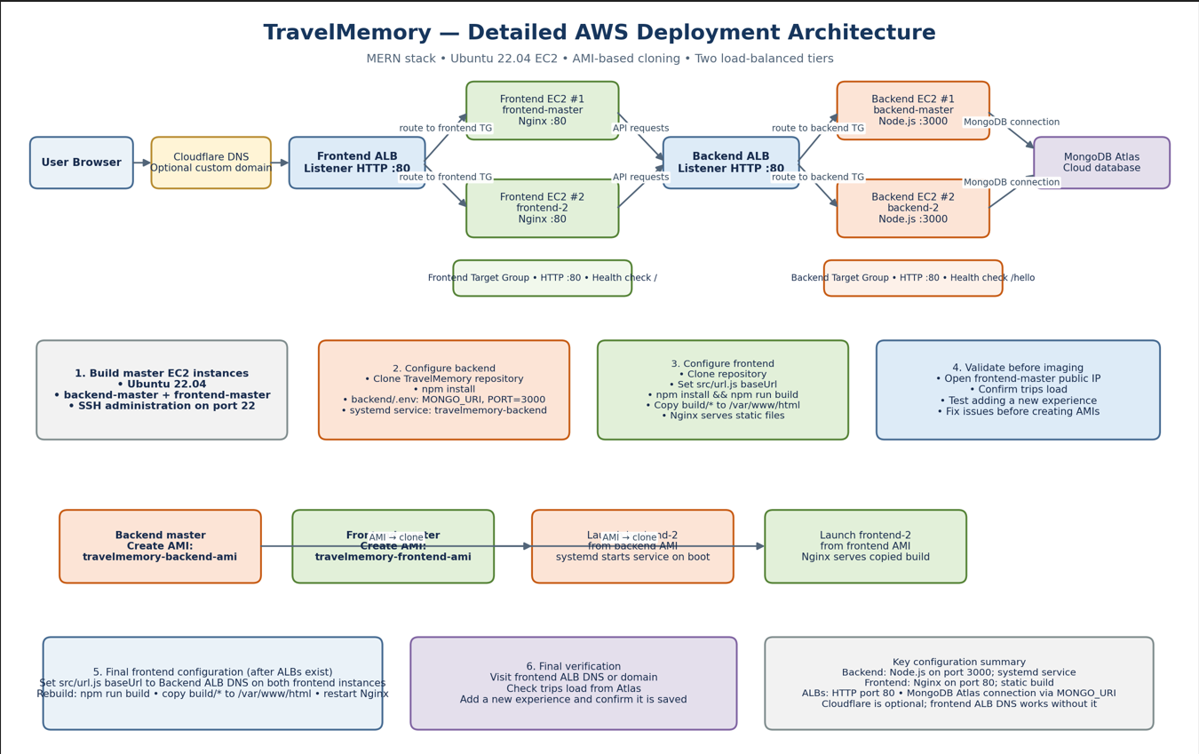
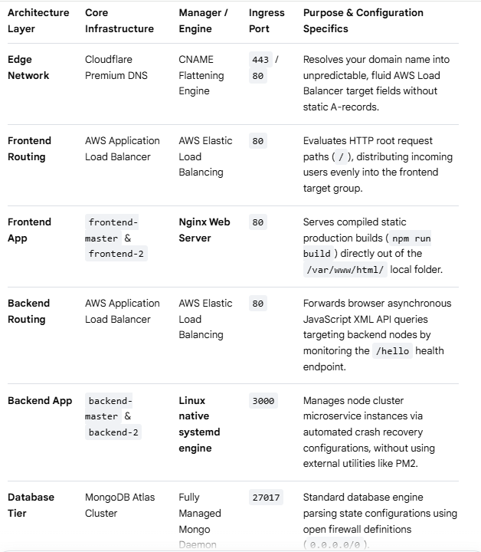
- MONGO DB
Create a free cluster MONGODB
Sign in to cloud.mongodb.com web site and create a project.
Create a cluster named travel Memory.

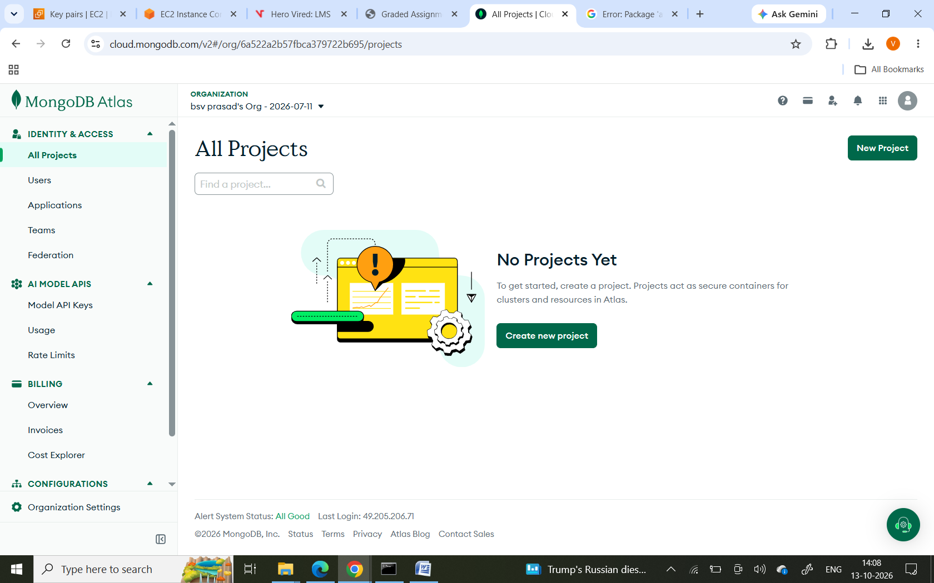
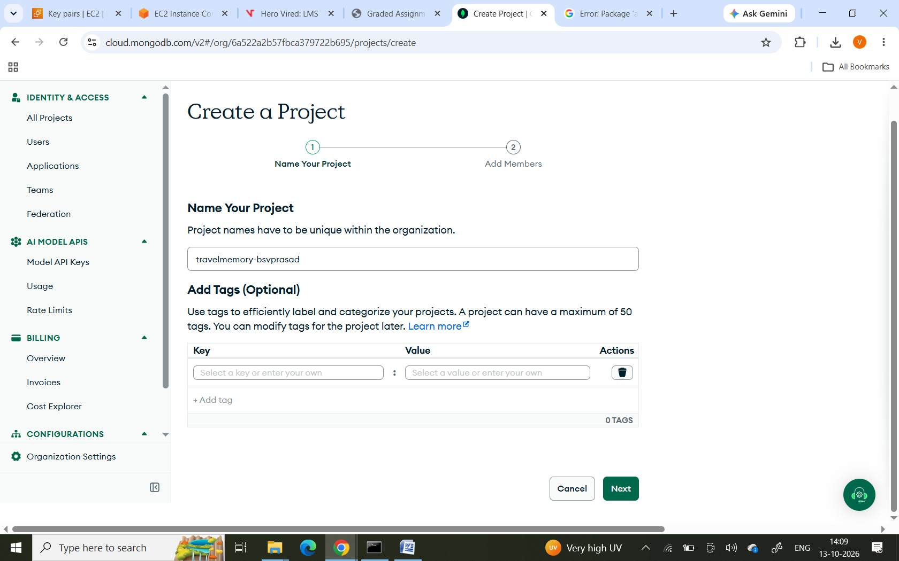

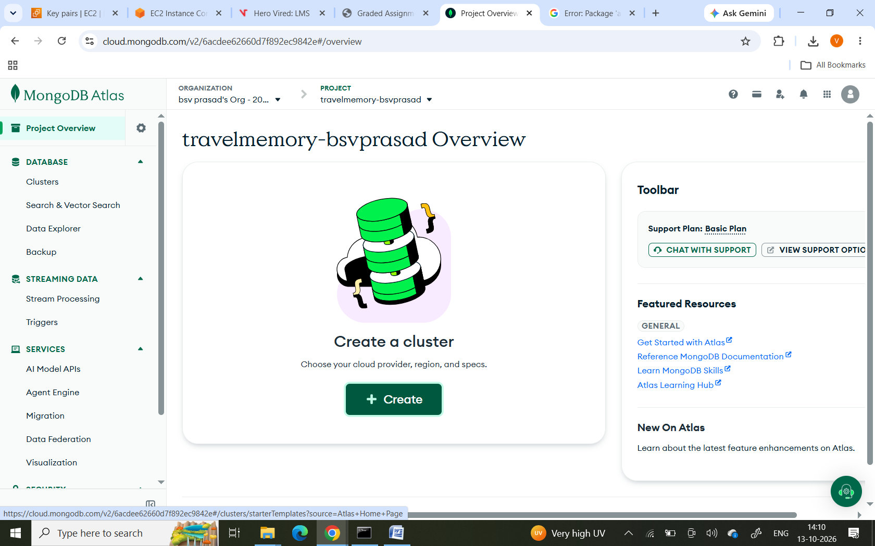
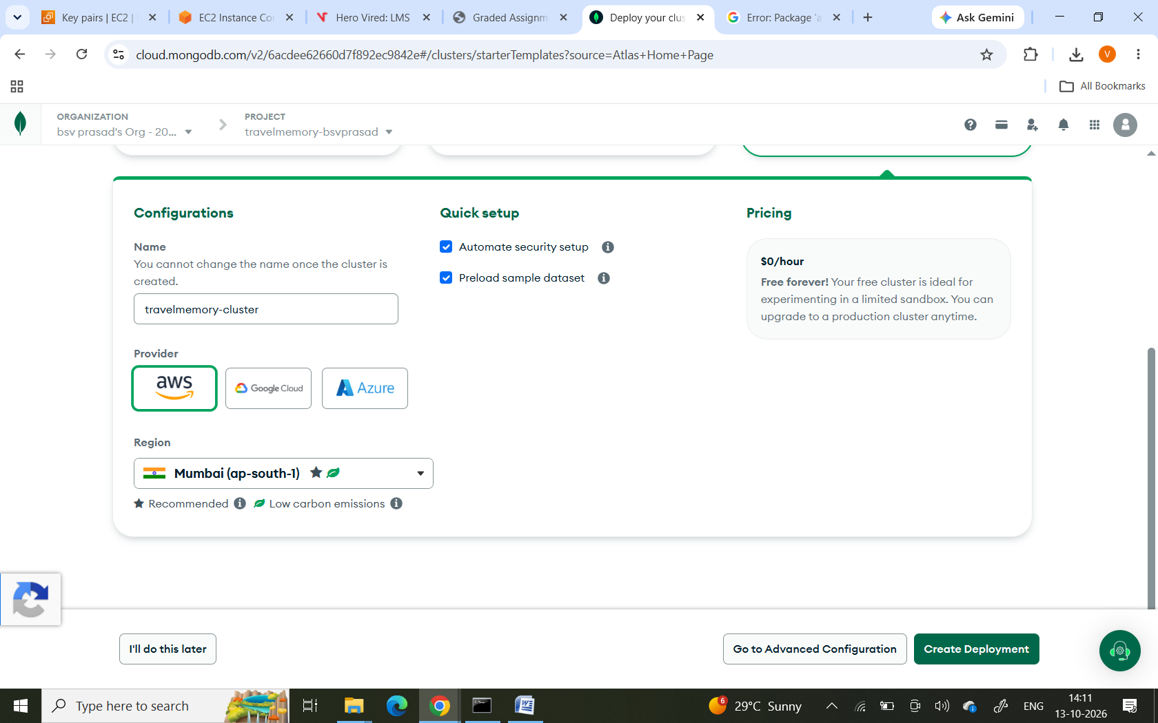
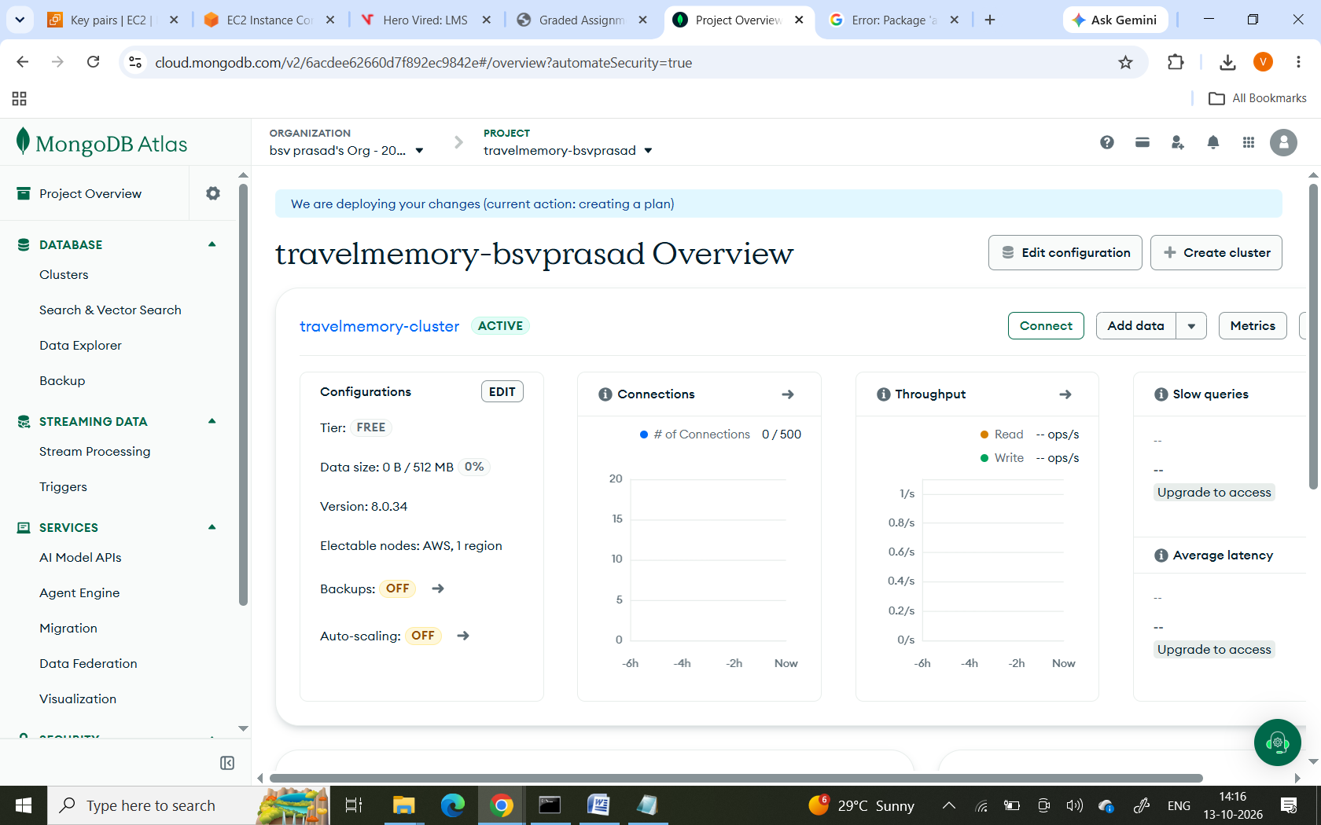

Go to MONGODB COMPASS
Add New Database User → set username/password
Connect
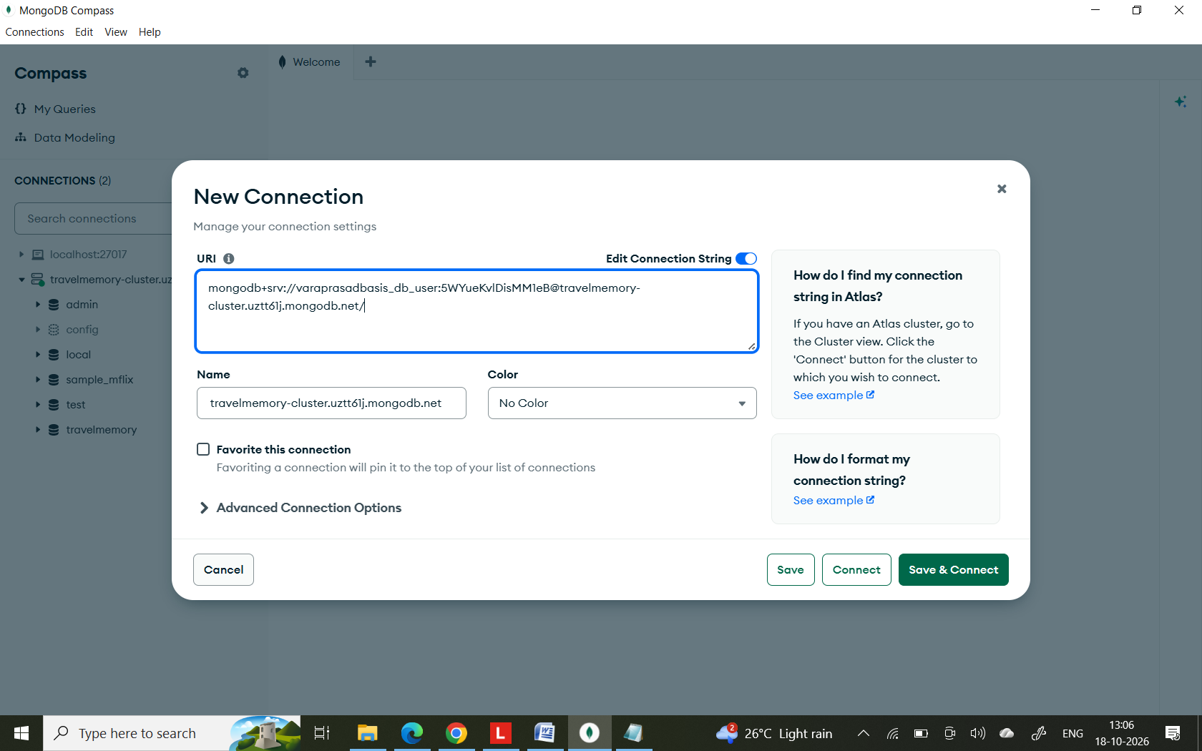
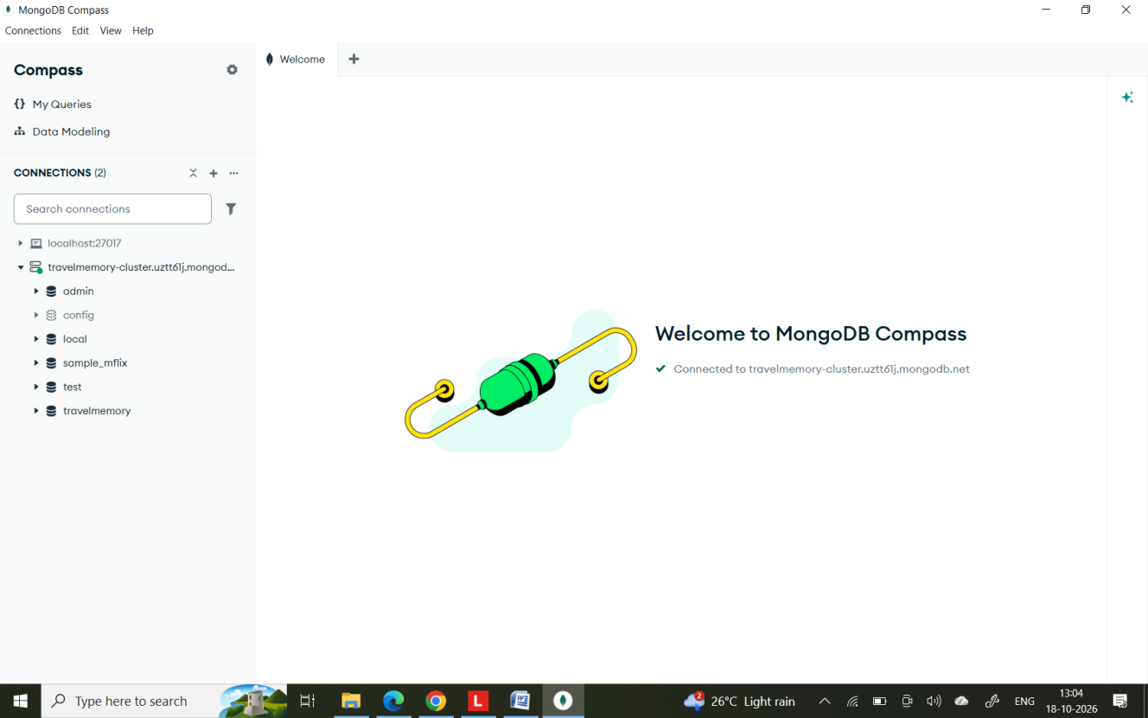

Network Access → Add IP Address → 0.0.0.0/0 (allow access from anywhere, since EC2 IPs vary).

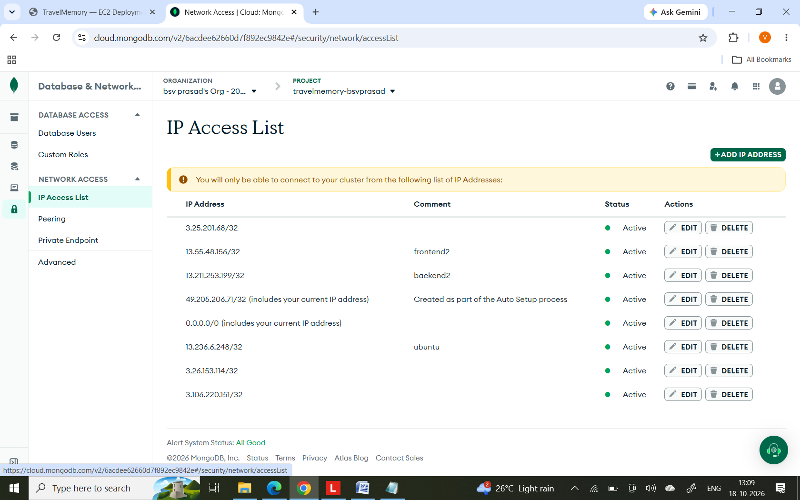

Creating AWS EC2 instances
one backend and one frontend instance first — these become the templates (AMIs) for everything you scale later.
Launch a Ubuntu 22.04 EC2 instance for the backend — name it backend-master.
Launch a second Ubuntu 22.04 EC2 instance for the frontend — name it frontend-master.

Login to AWS -> go to EC2 Instances-> Launch instance
name : backend-master
OS : Ubuntu 22.04
Type :t3.micro

name : frontend-master
OS : Ubuntu 22.04
Type :t3.micro

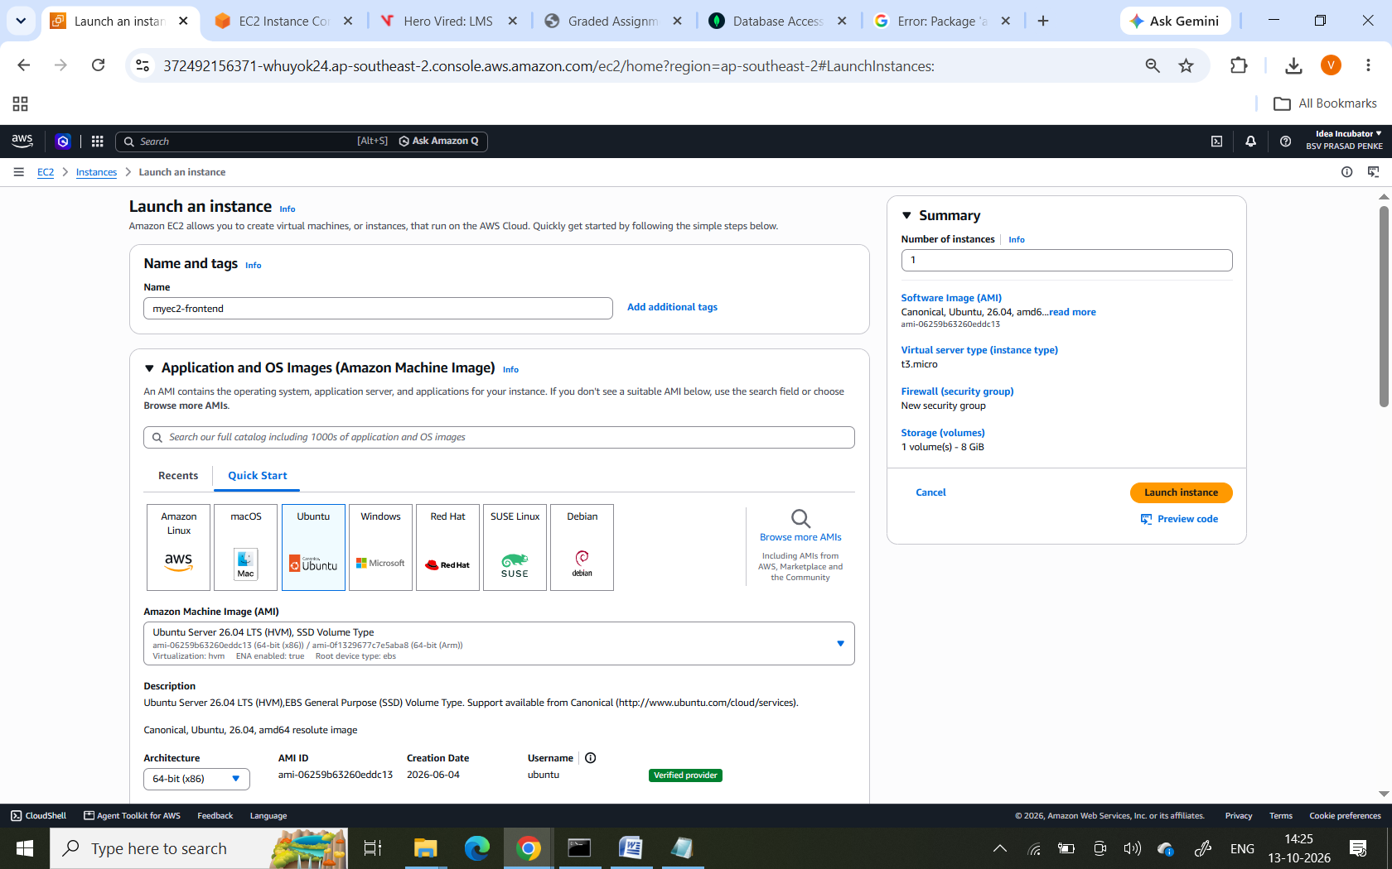
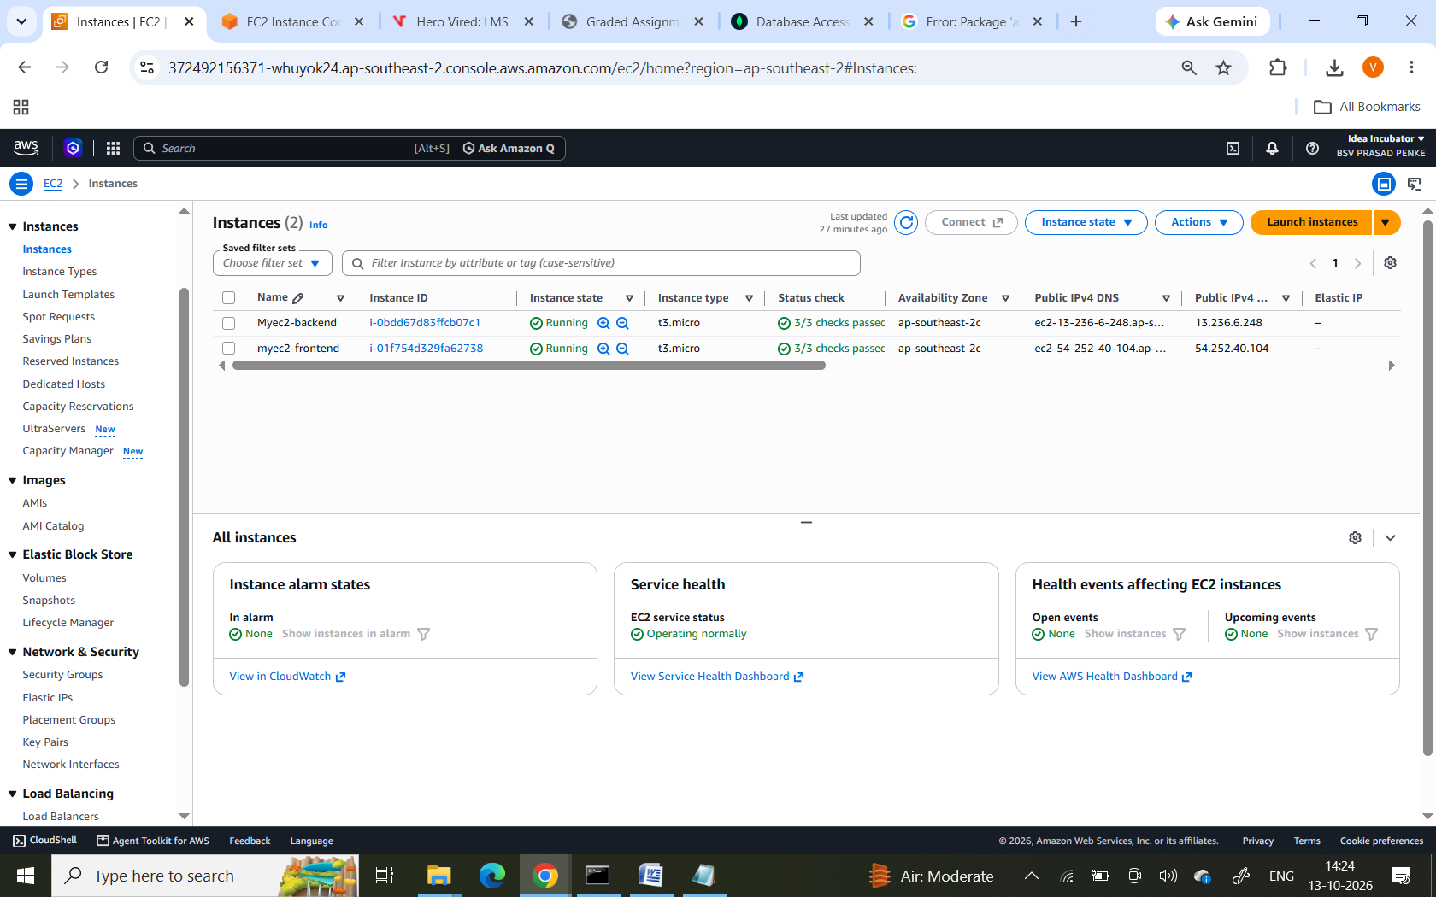
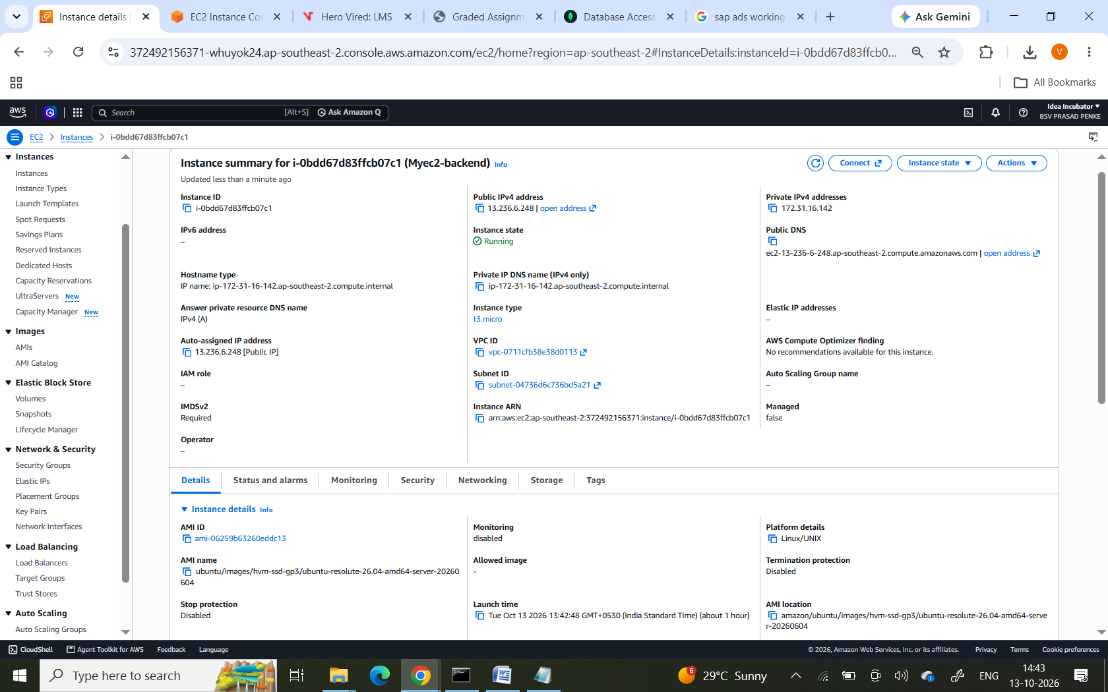
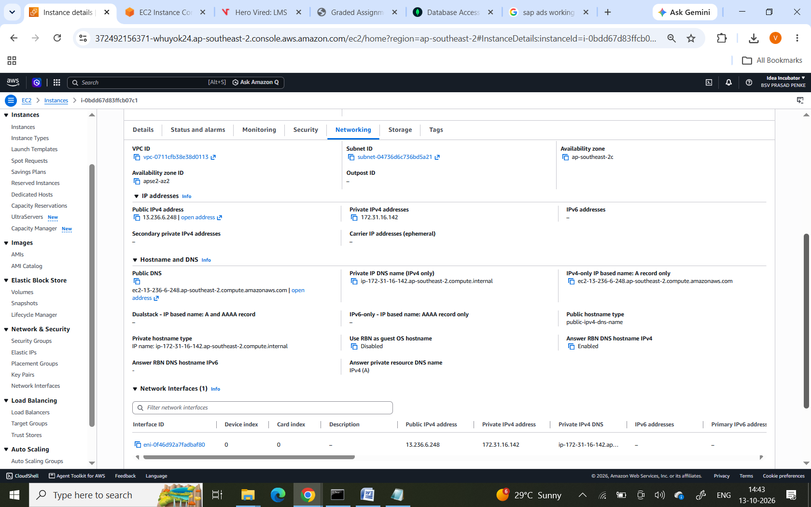
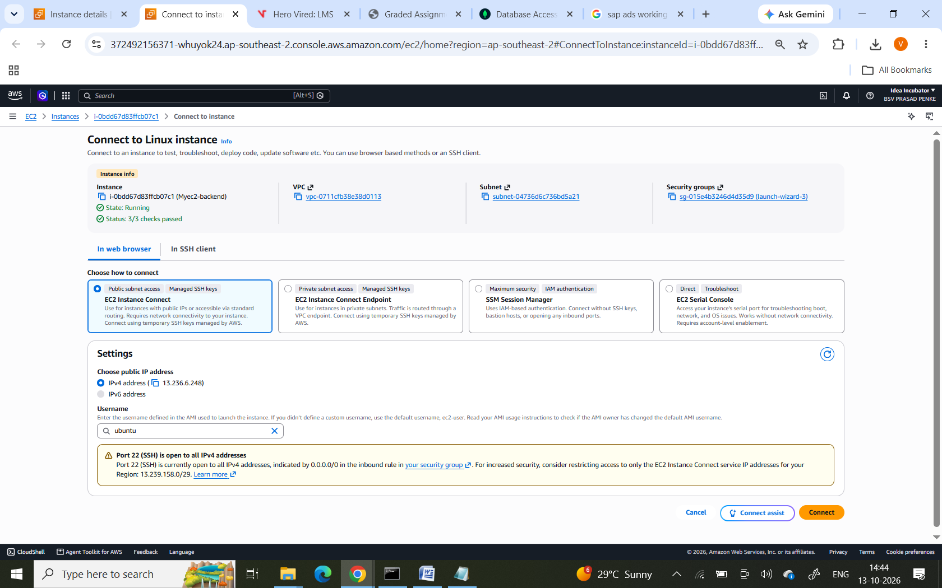
Login to CLI
Run sudo apt update.
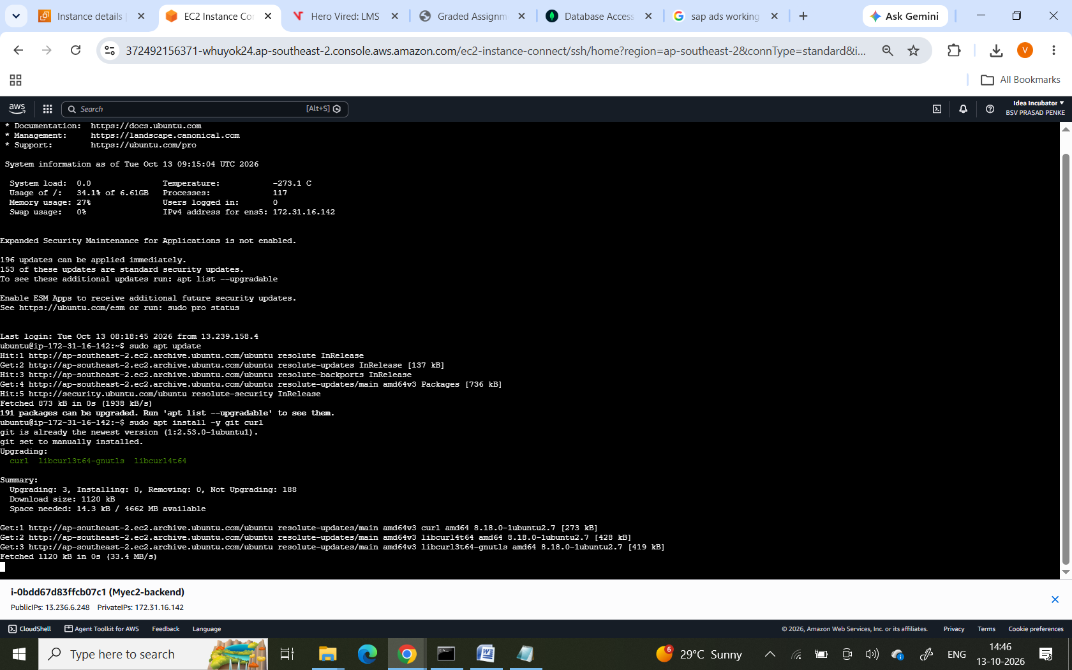
Sudo apt install node.js
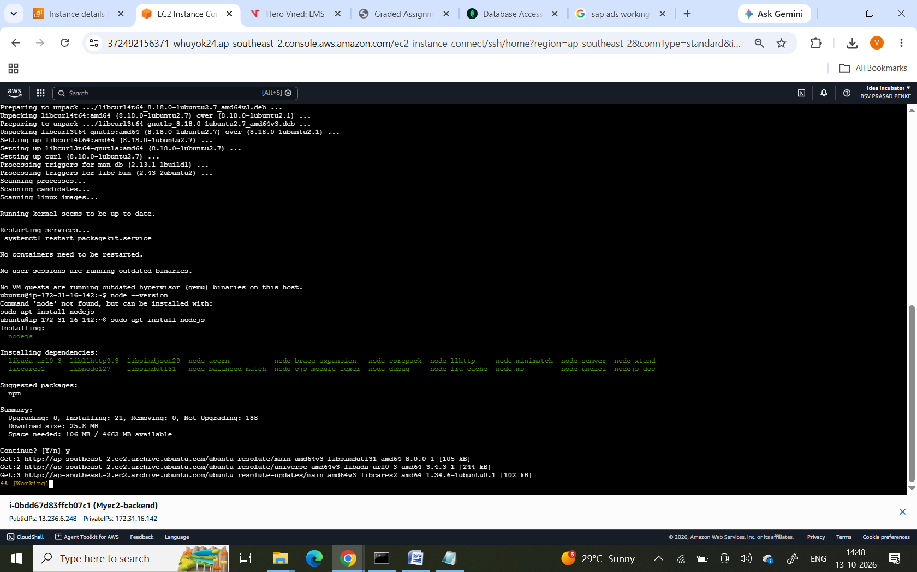
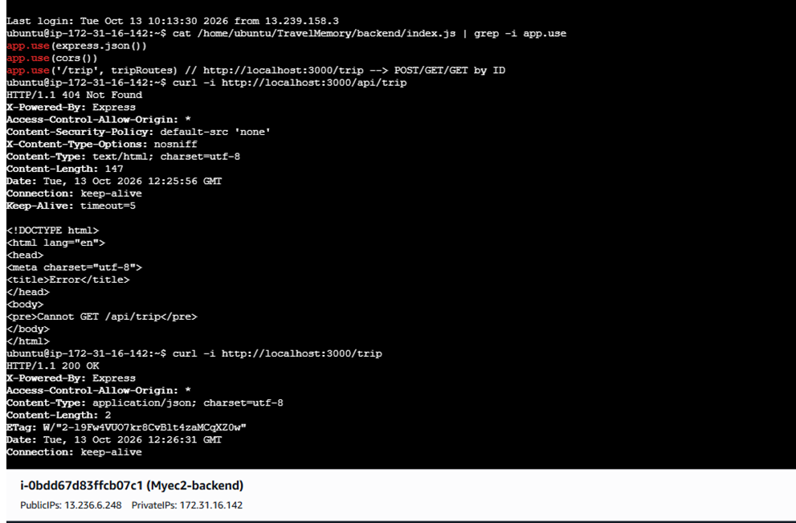
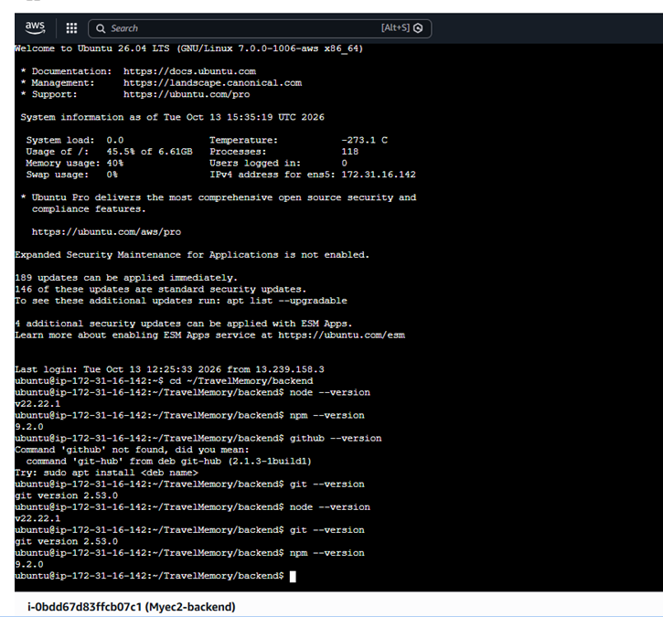
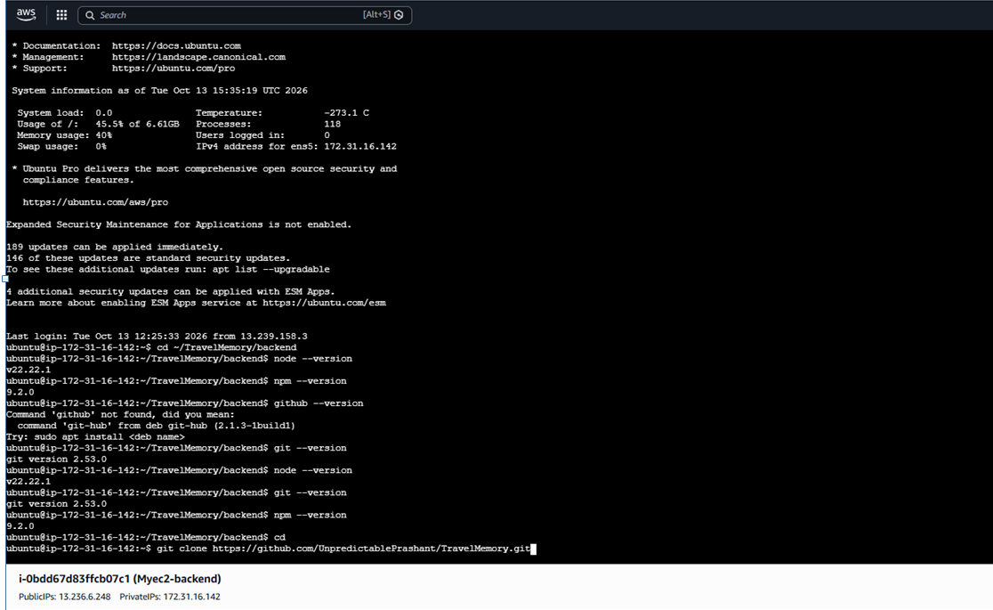
cd TravelMemory/backend

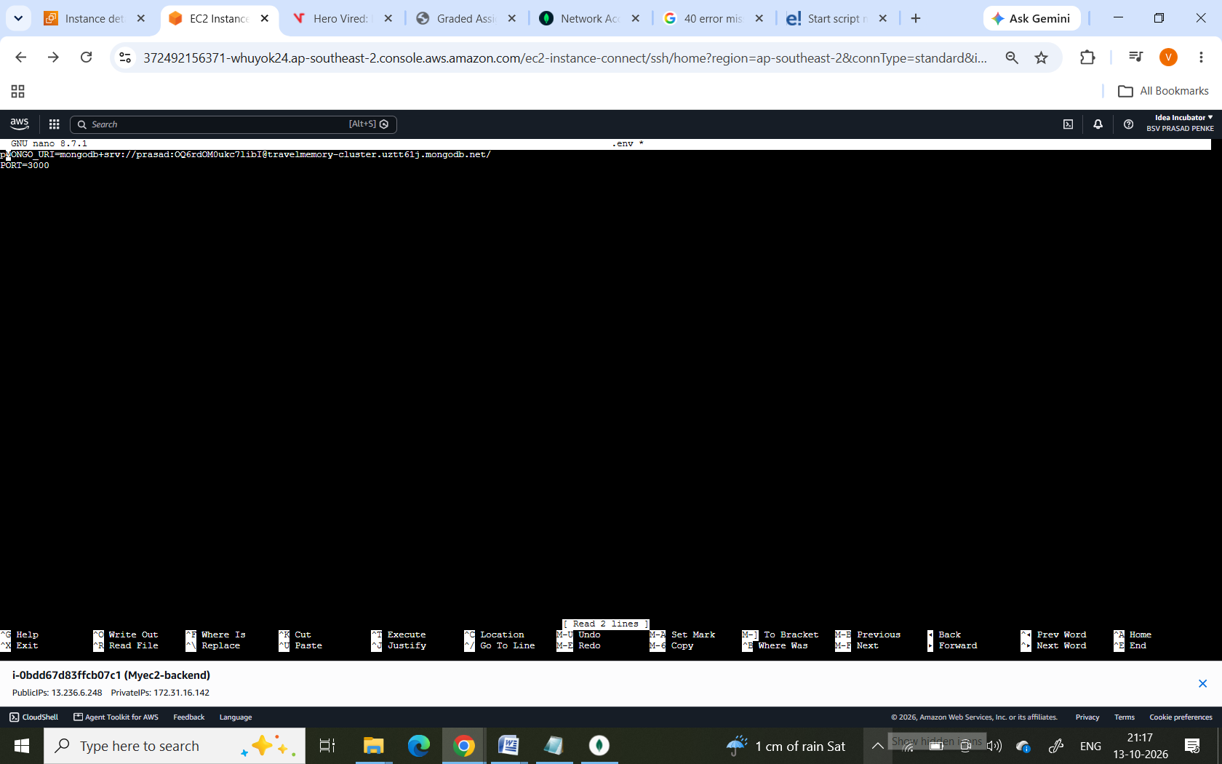

Configure the backend to start automatically

The guide specifies a systemd service named travelmemory-backend, so the application can start automatically when the instance restarts.

Save it as /etc/systemd/system/travelmemory-backend.service. Confirm that ExecStart matches your installation's npm path and backend start script before using it.
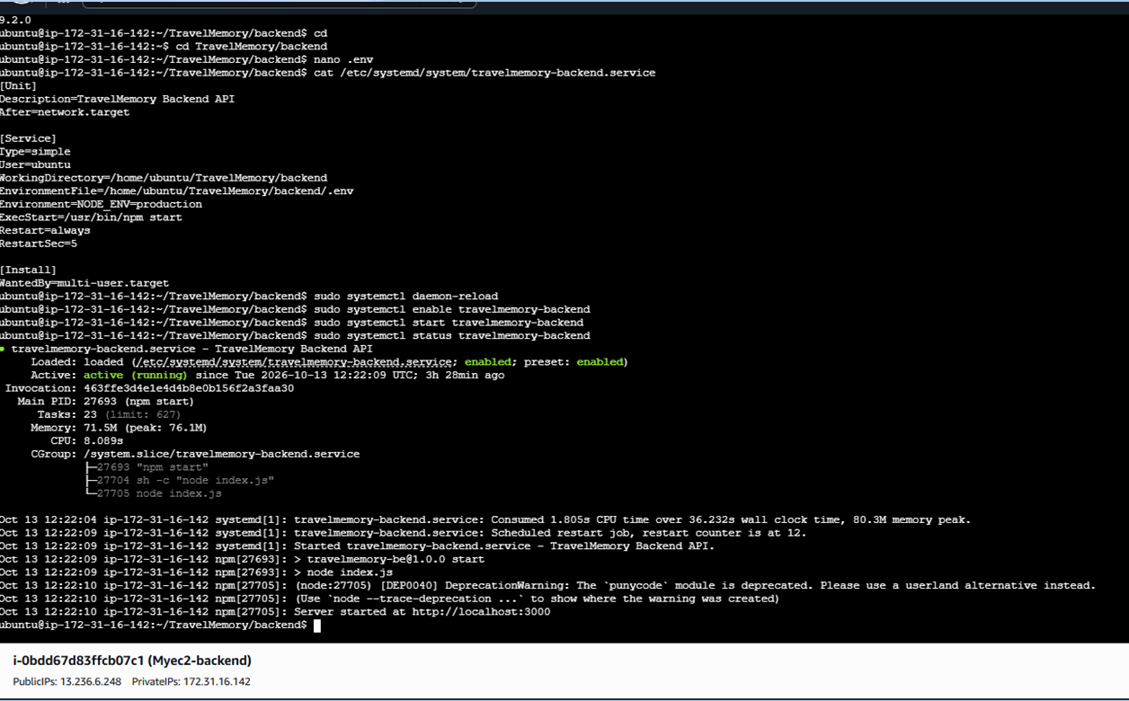
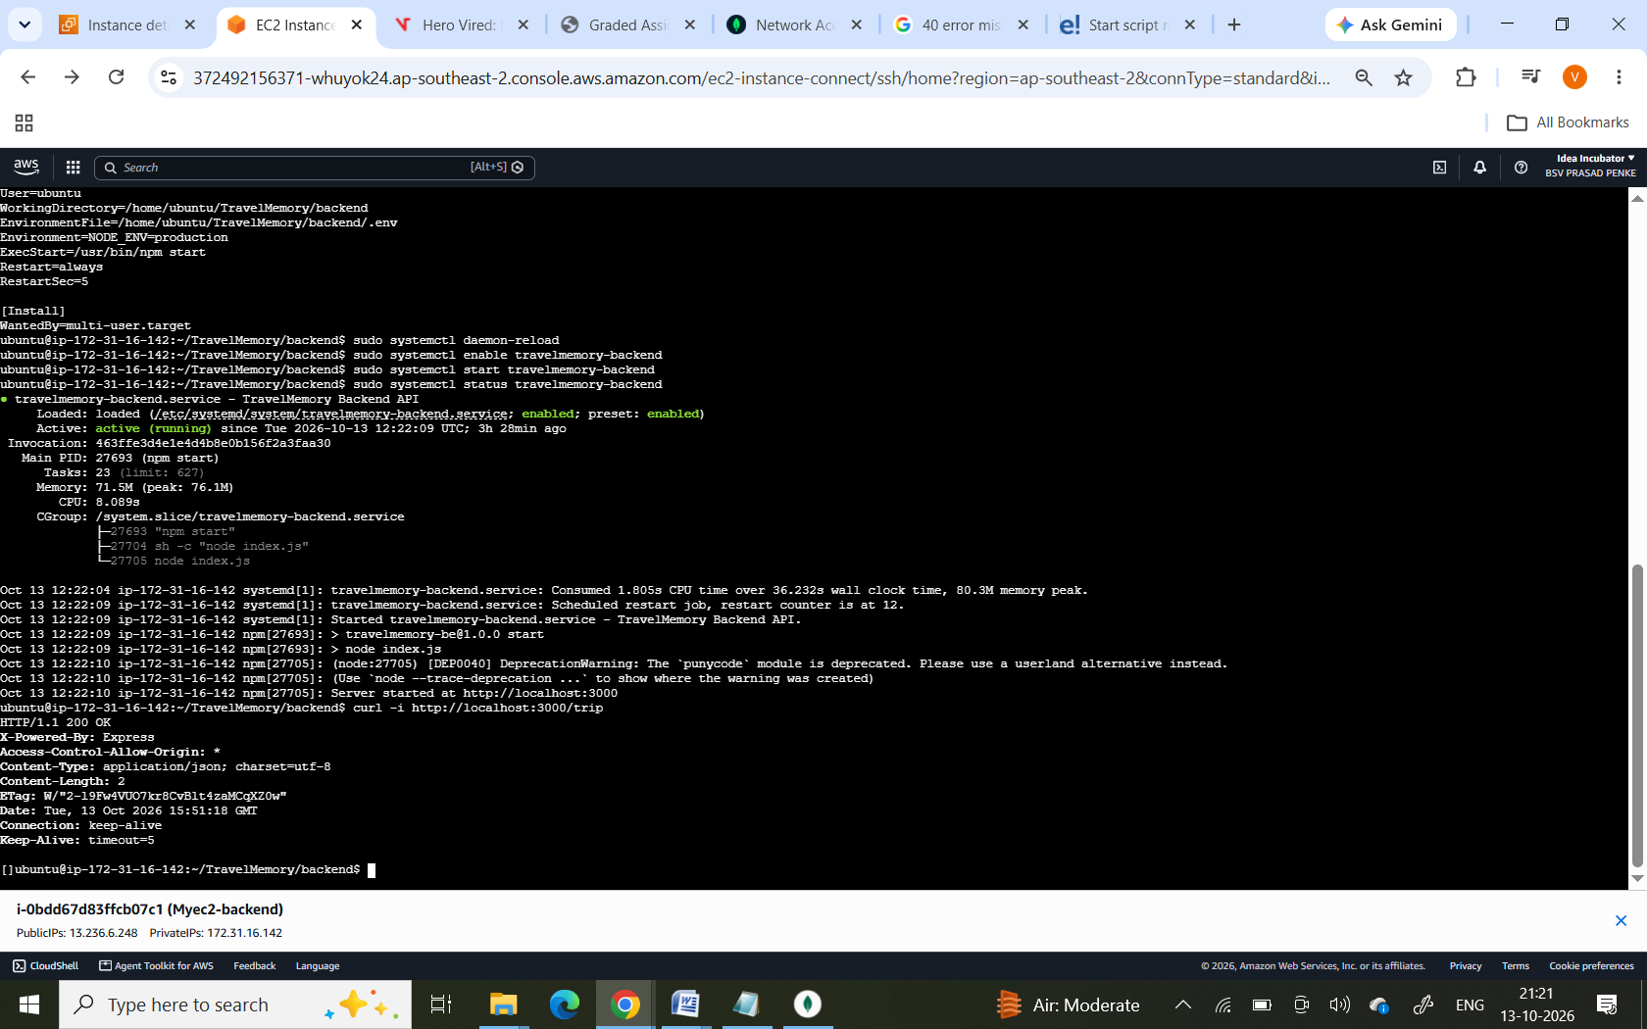
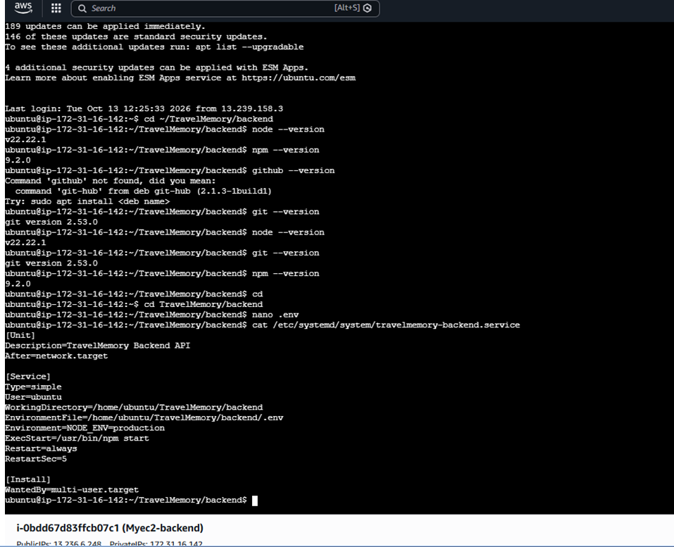

Configure the frontend server
Purpose: Build the user interface and serve it through Nginx.
Connect to frontend-master
Install Git, Node.js, npm, and Nginx if they are not already installed. Check their versions and service status.
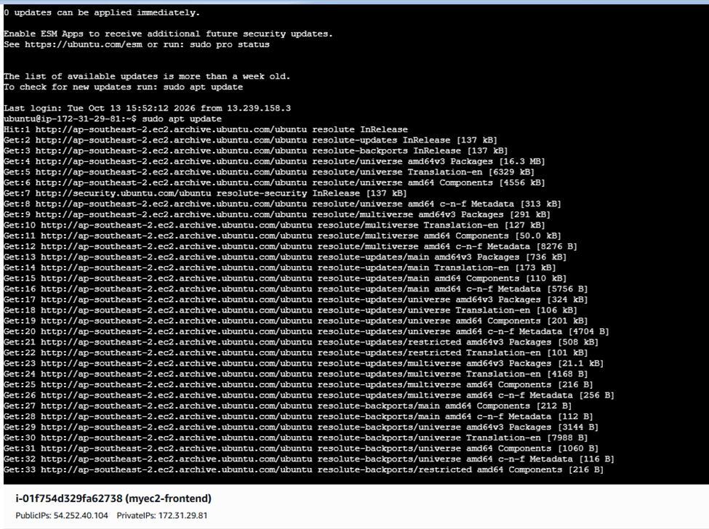
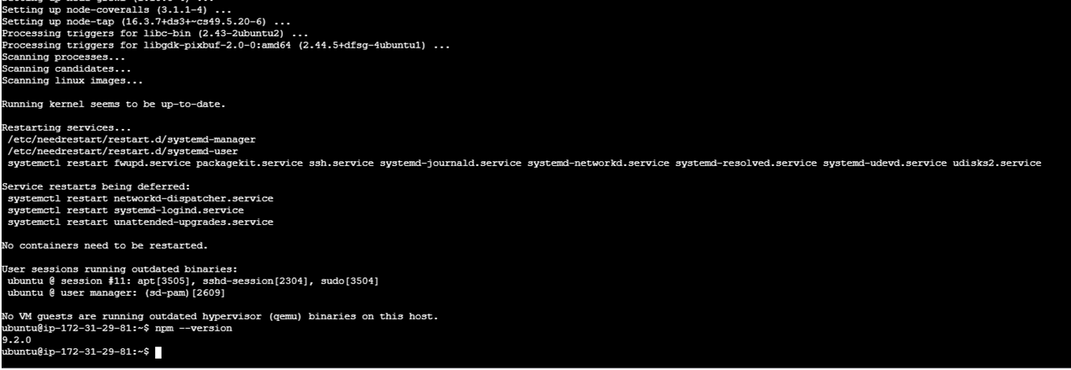
Set .env file ->type nano .env -> update backend MONDG DB cluster connection string 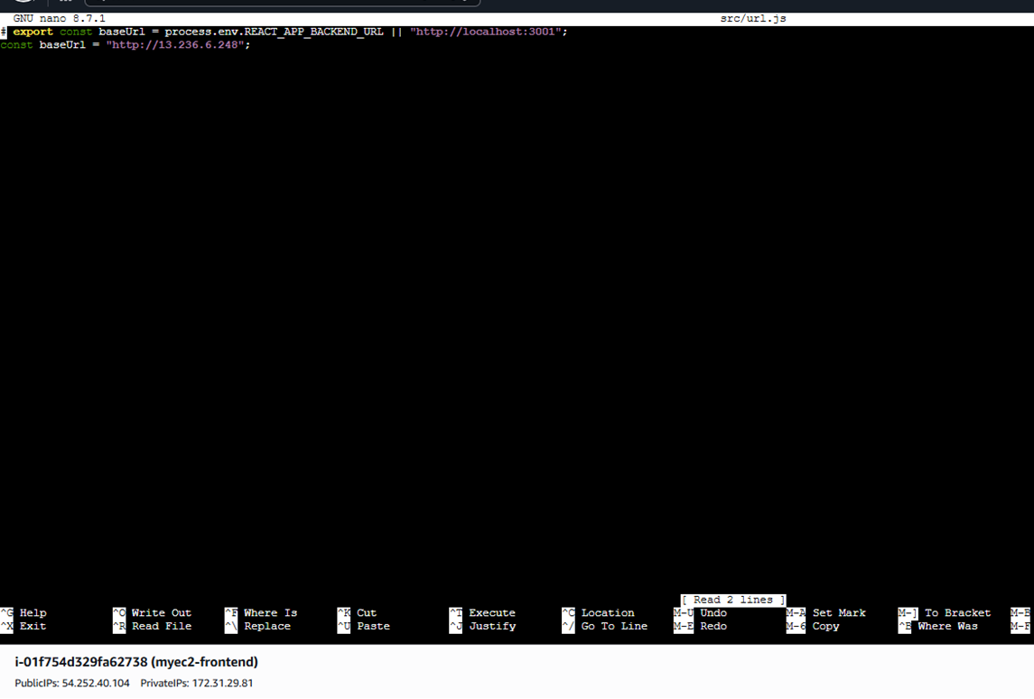
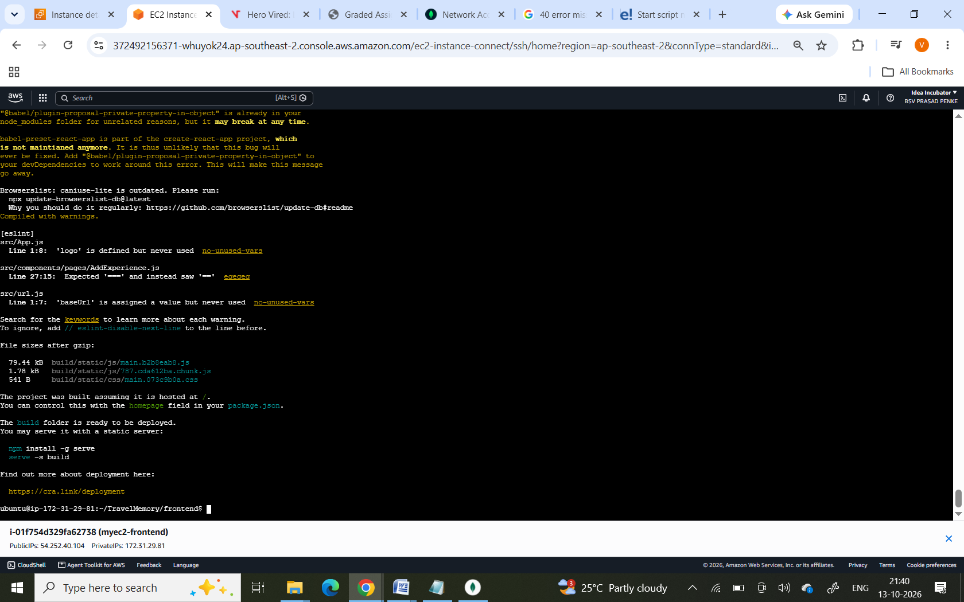
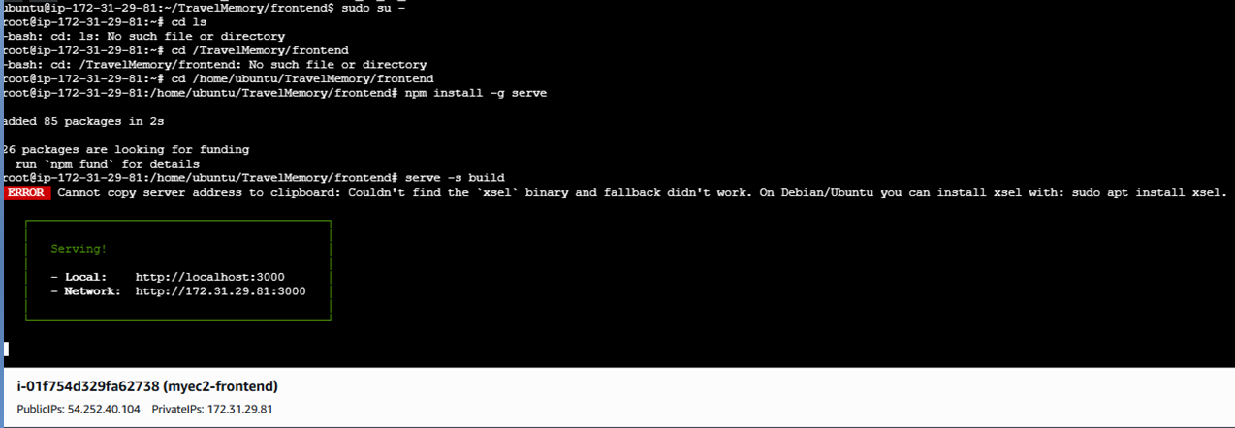
Run npm build and ublish the frontend using Nginx
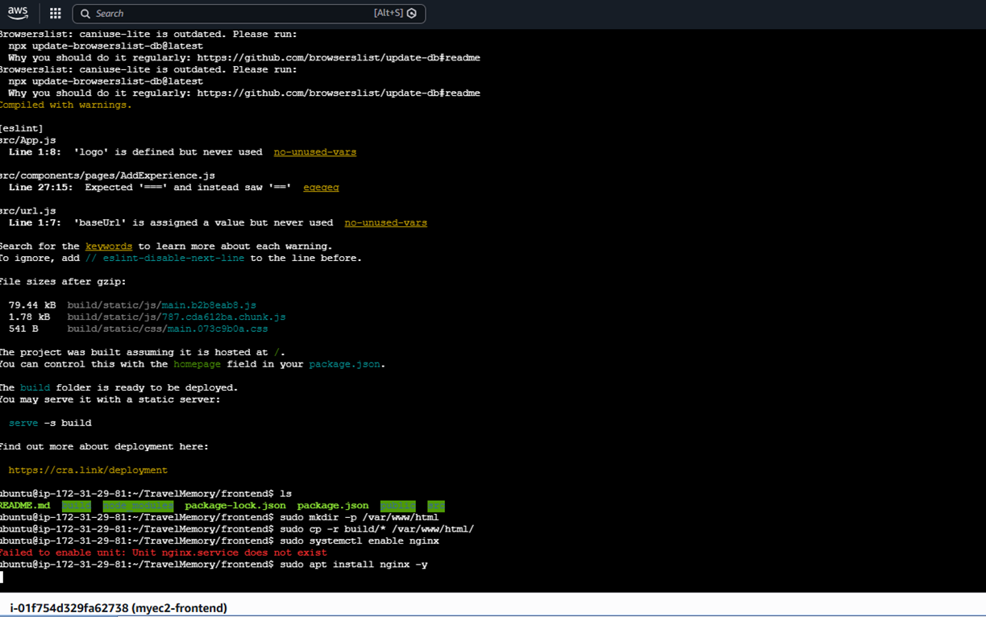

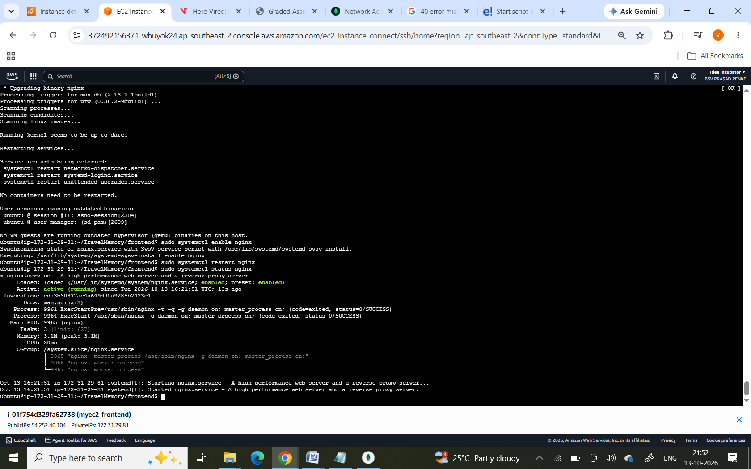
Verify the initial application
You should see the Travel Memory application page.
- If the page opens, your frontend is accessible.
- If the page does not open, check that Nginx is running and the EC2 security group allows inbound HTTP traffic on port 80.
- Open browser run http://backend-IP

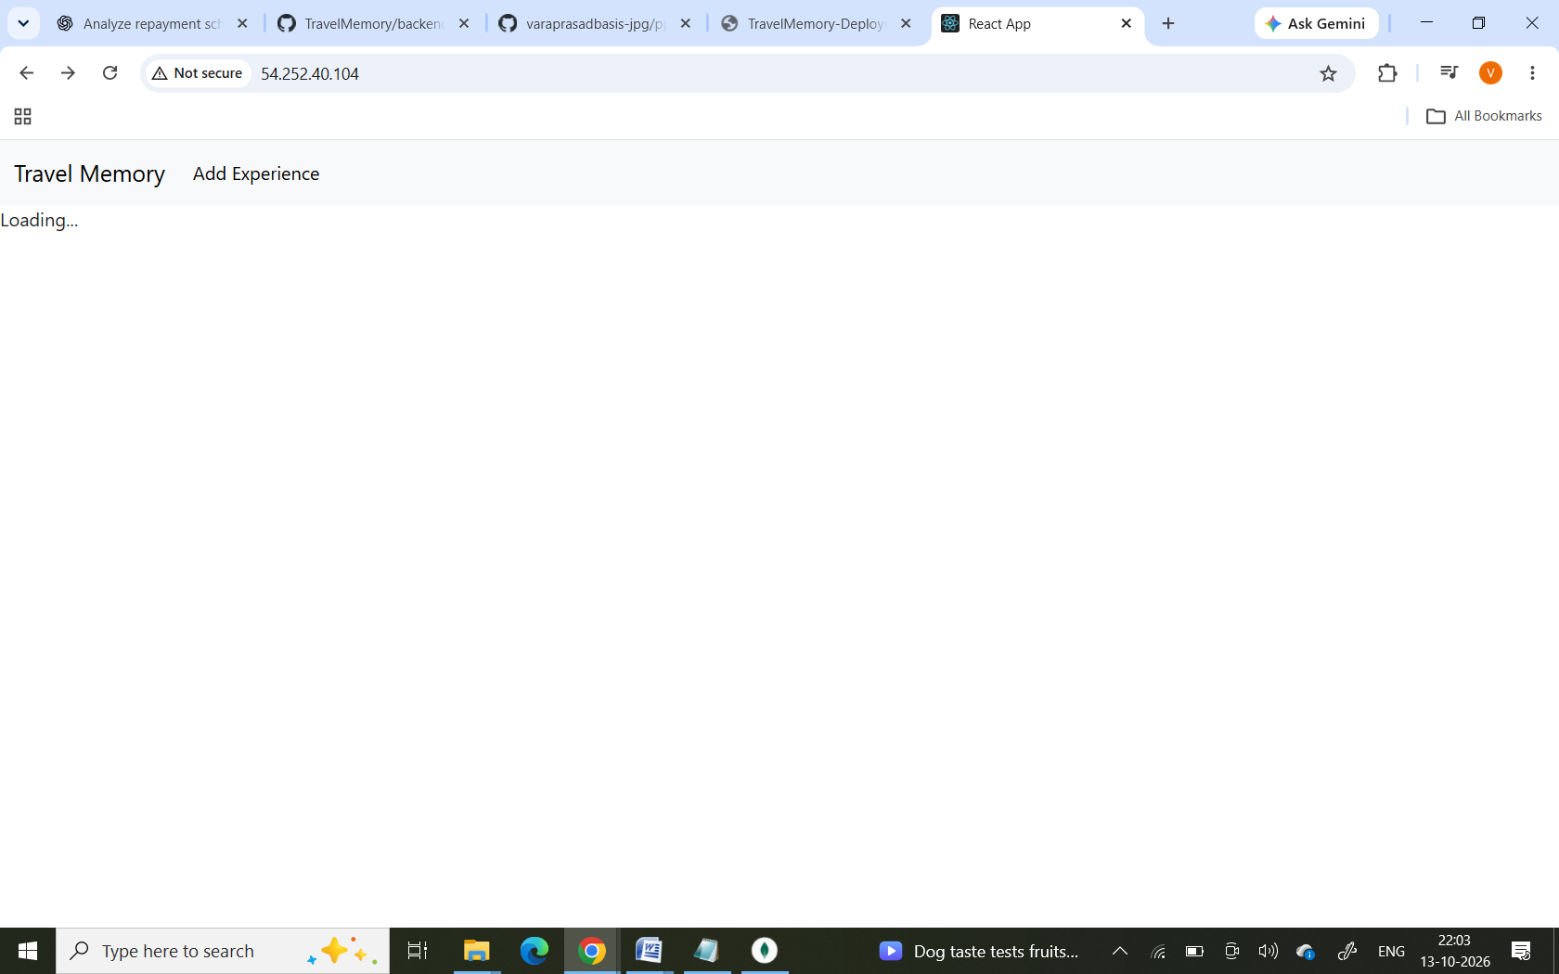
Create Amazon Machine Images (AMIs)
backend AMI image creation named backen2
frontend AMI creation named fronend2
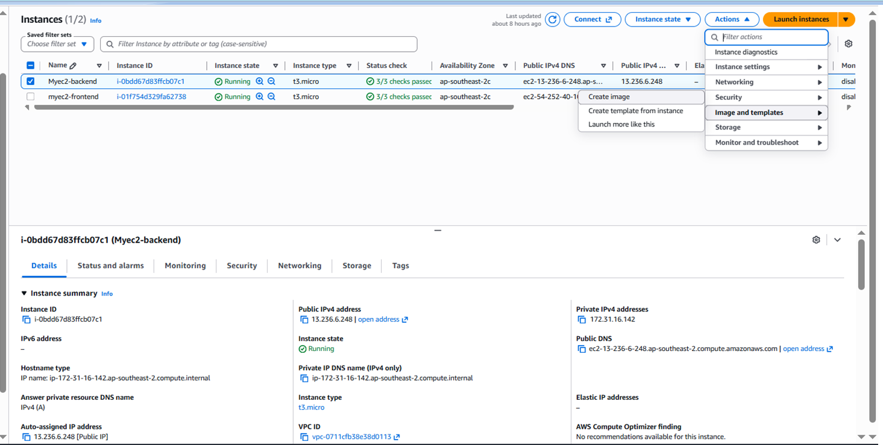
Frontend image
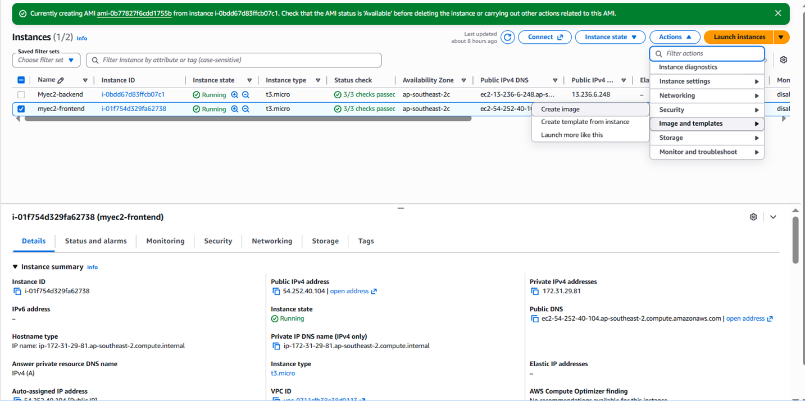
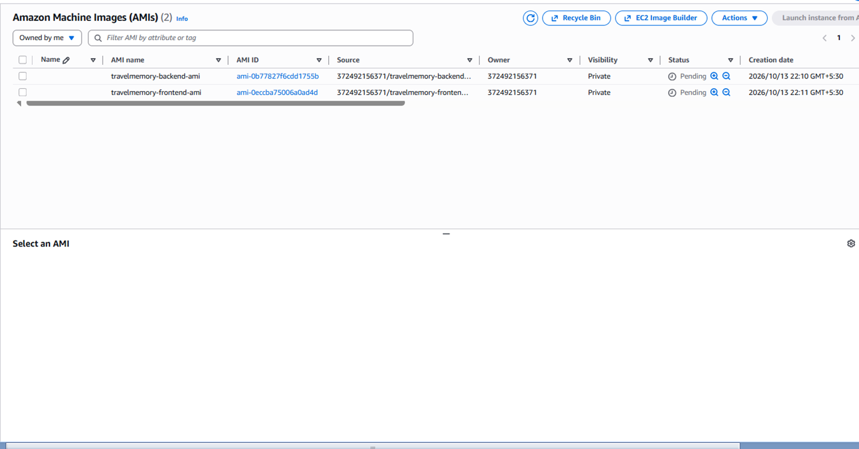

Launch the second pair of instances
Create two more EC2 instances using the AMIs you created.
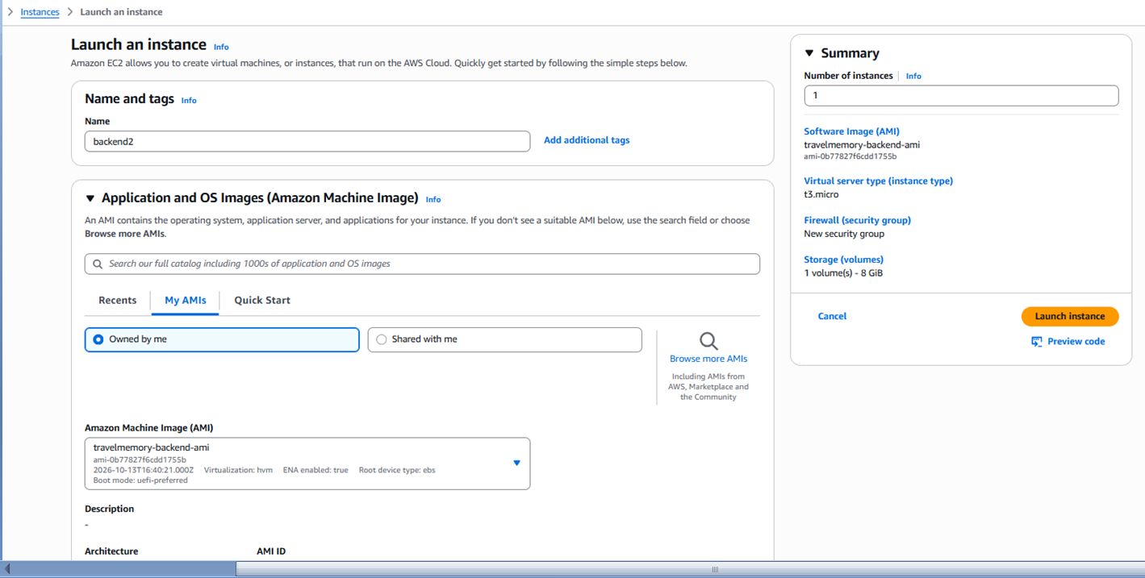

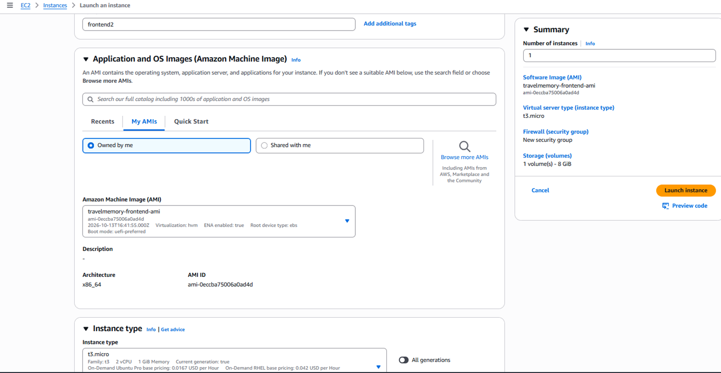
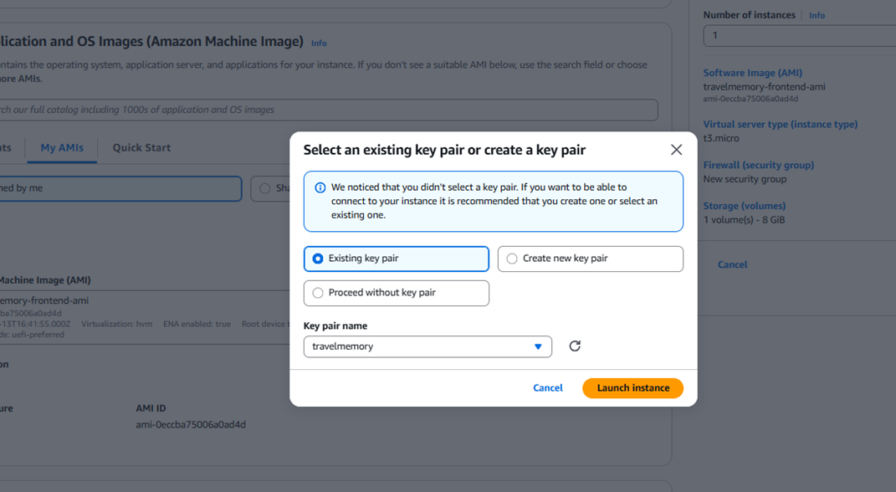

Target group Creation
Backend Target group:
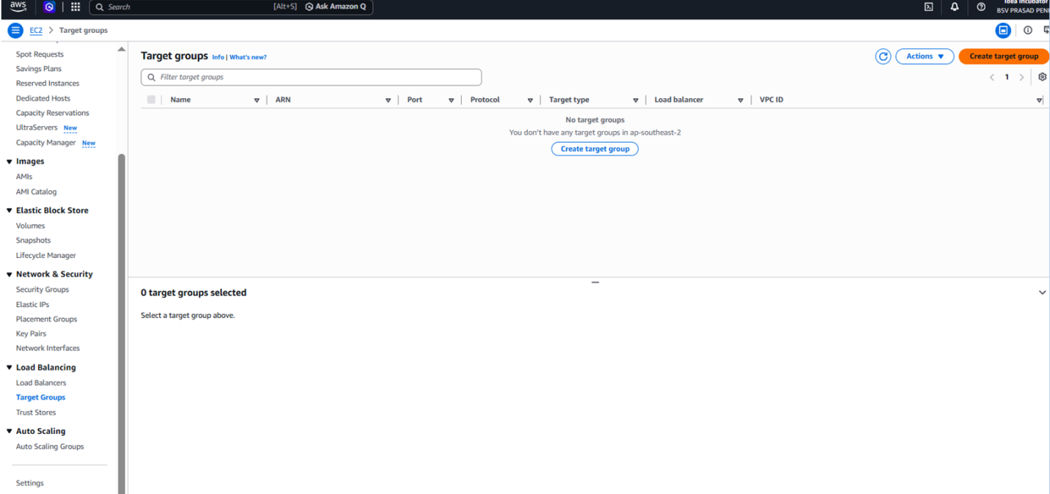
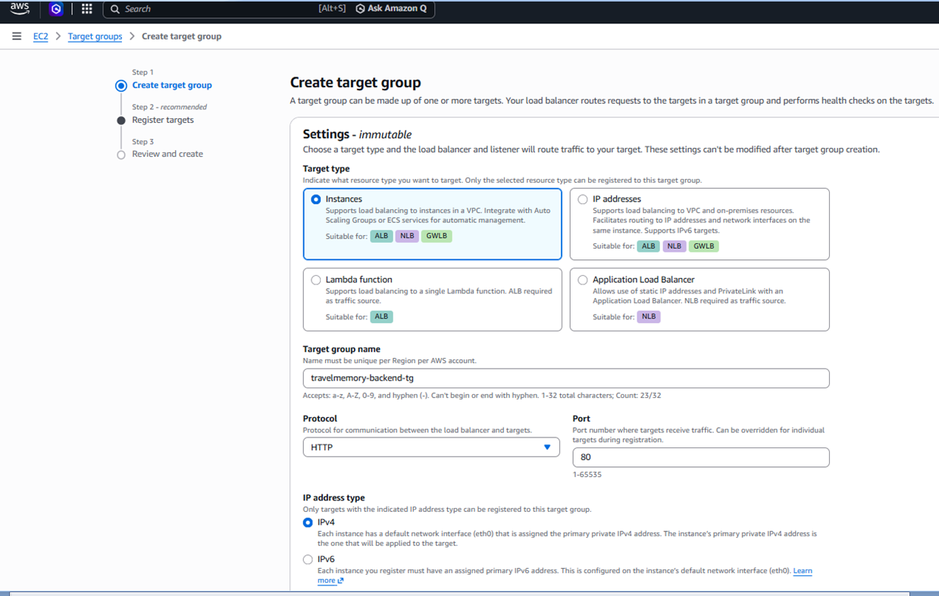
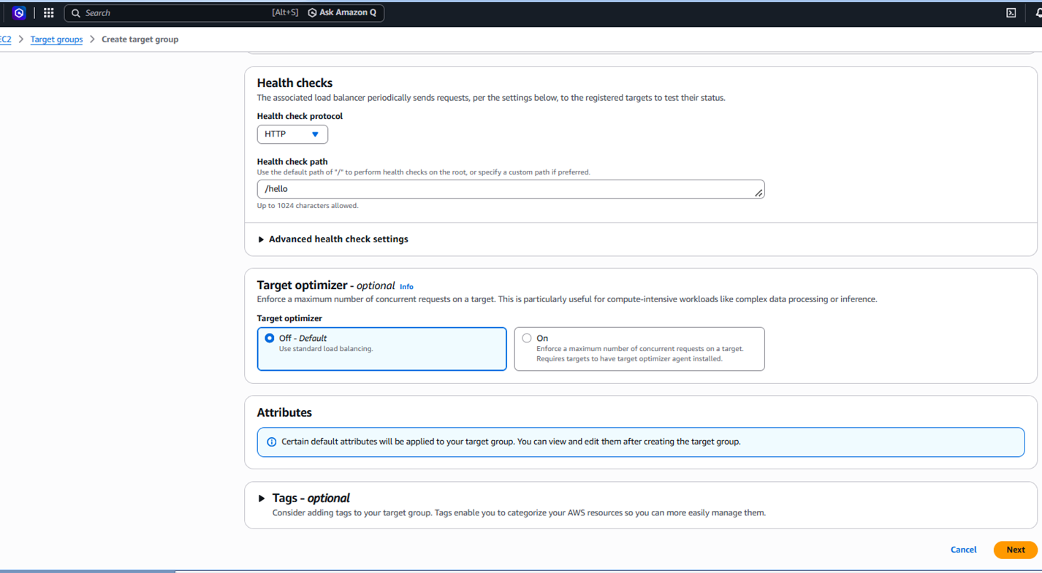
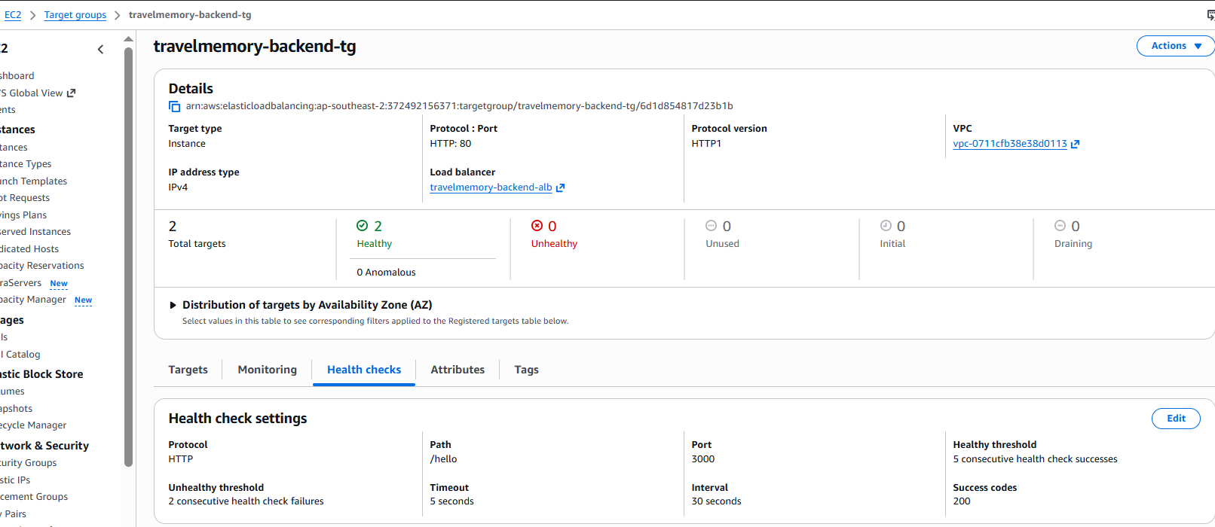

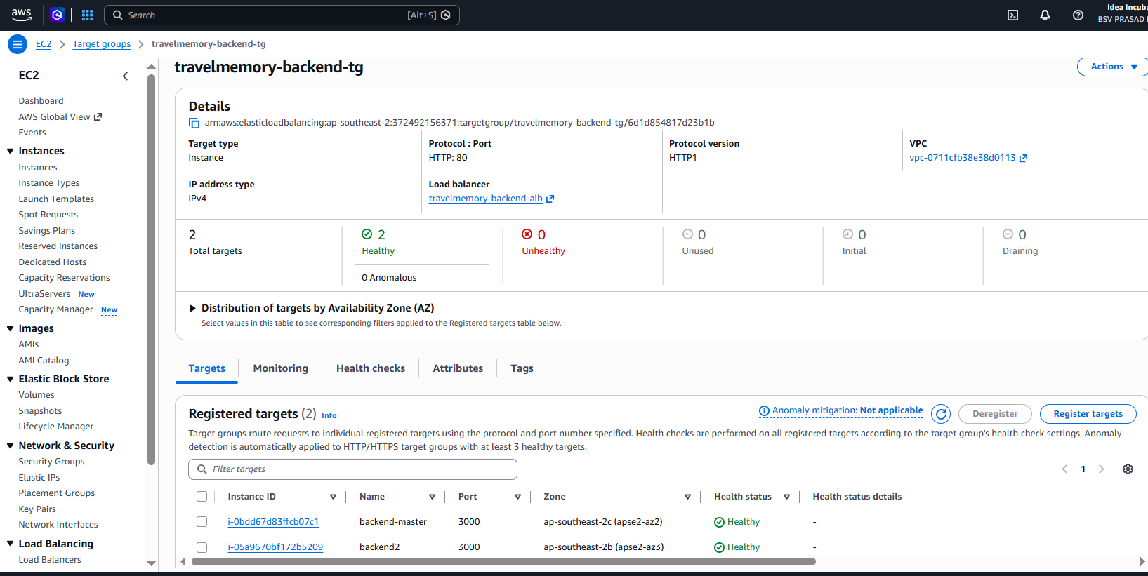
Frontend Target group
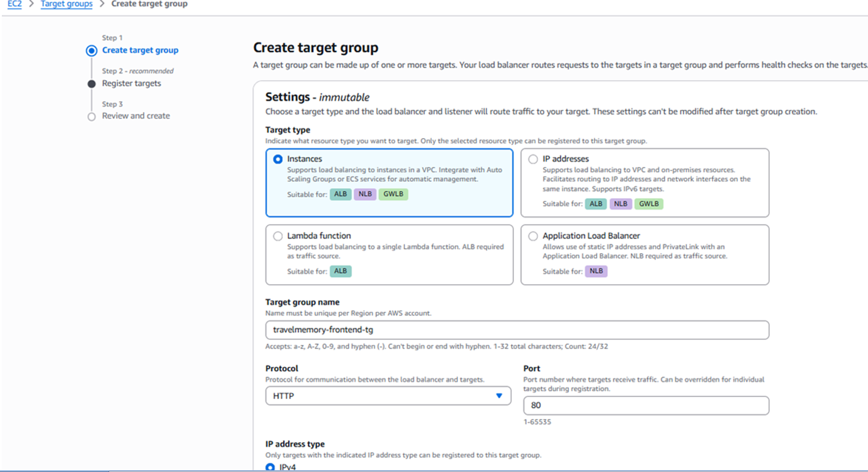
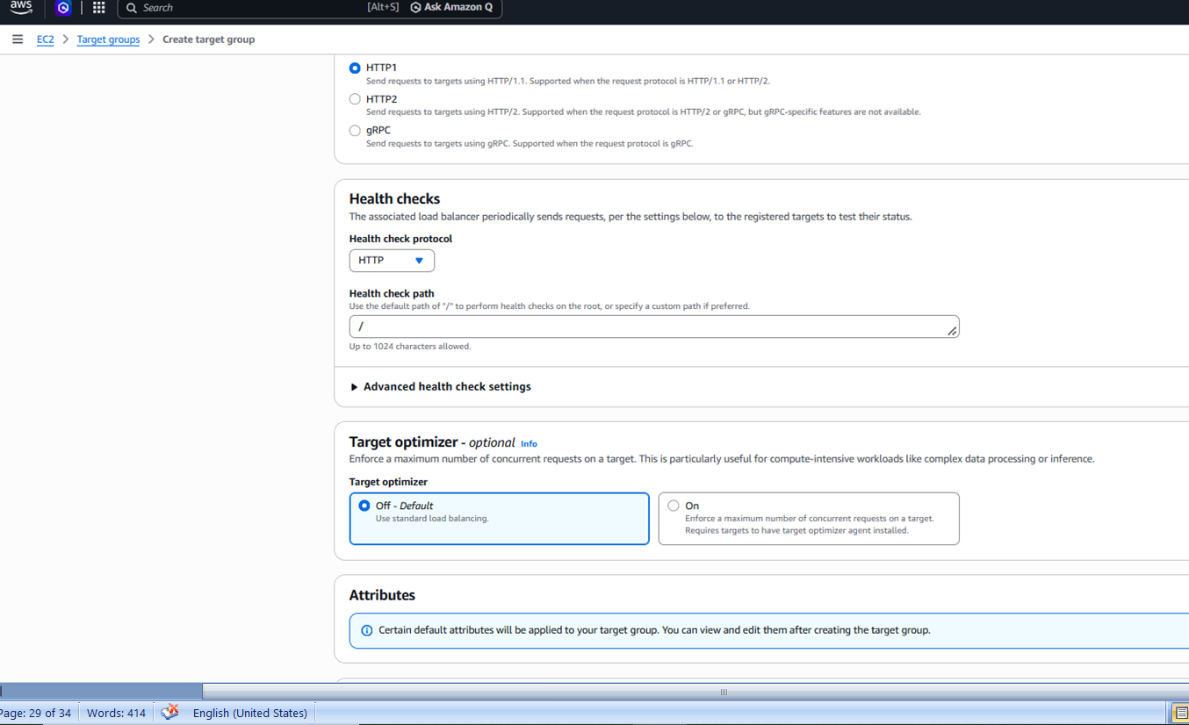

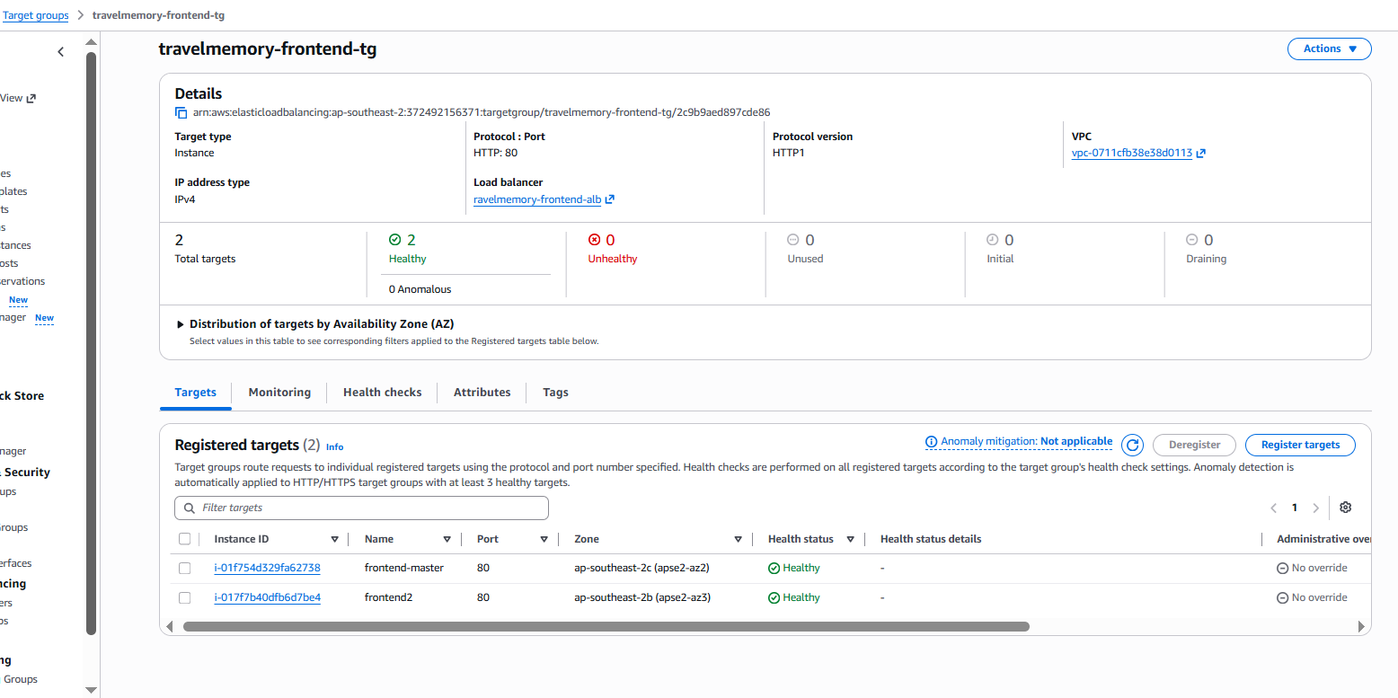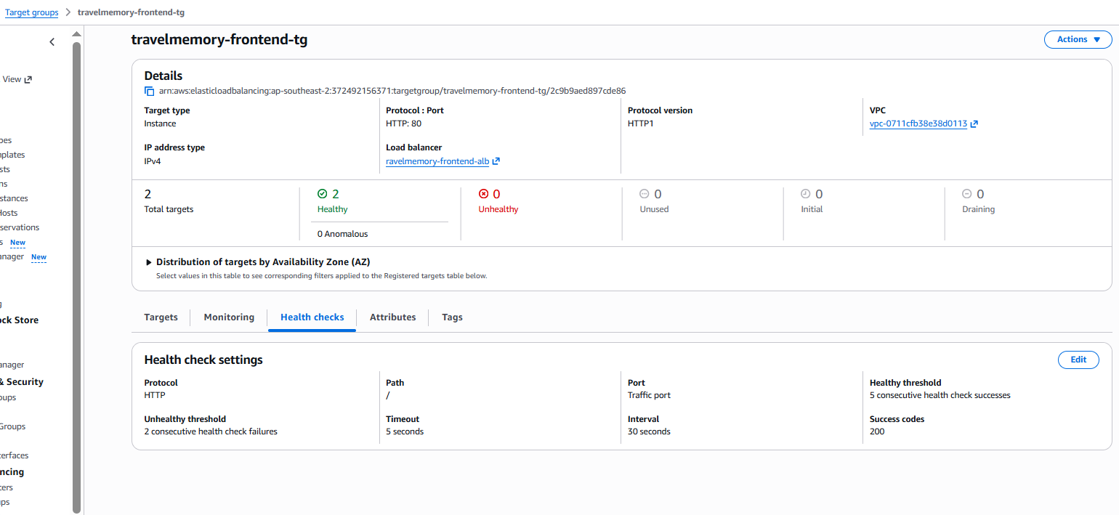

Create the backend Application Load Balancer
Go to EC2 → Load Balancers → Create load balancer → Application Load Balancer
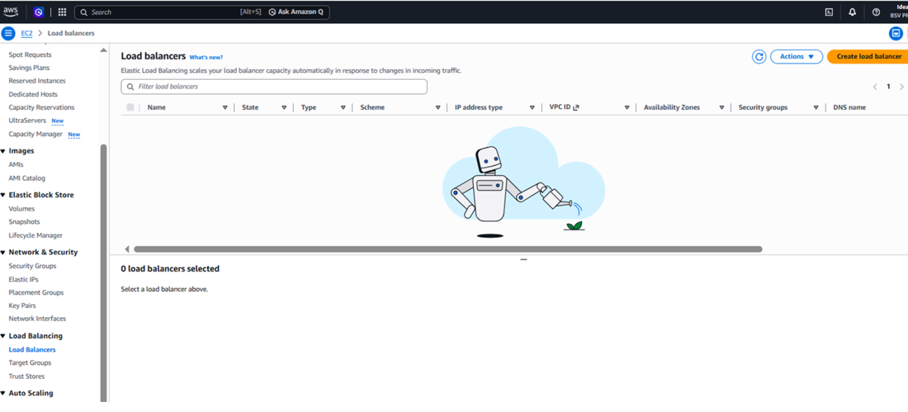
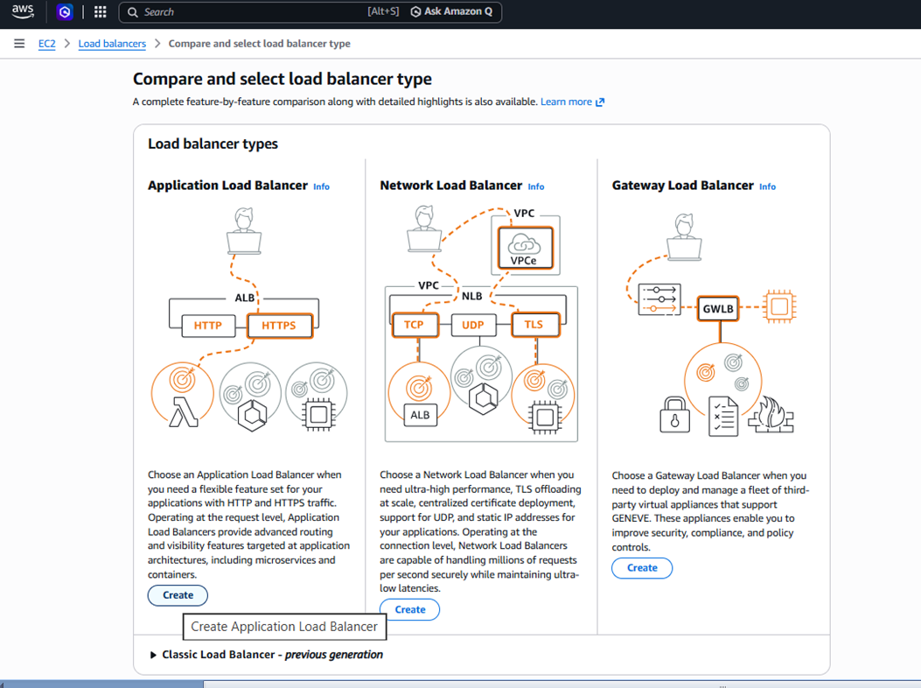
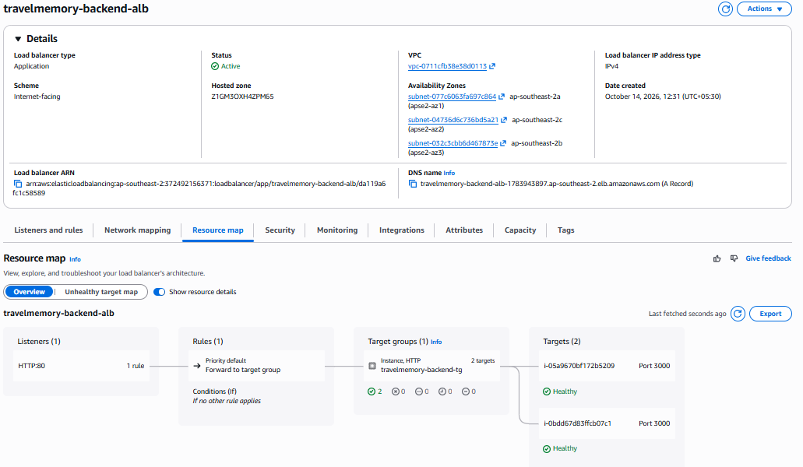
Create the frontend load balancer

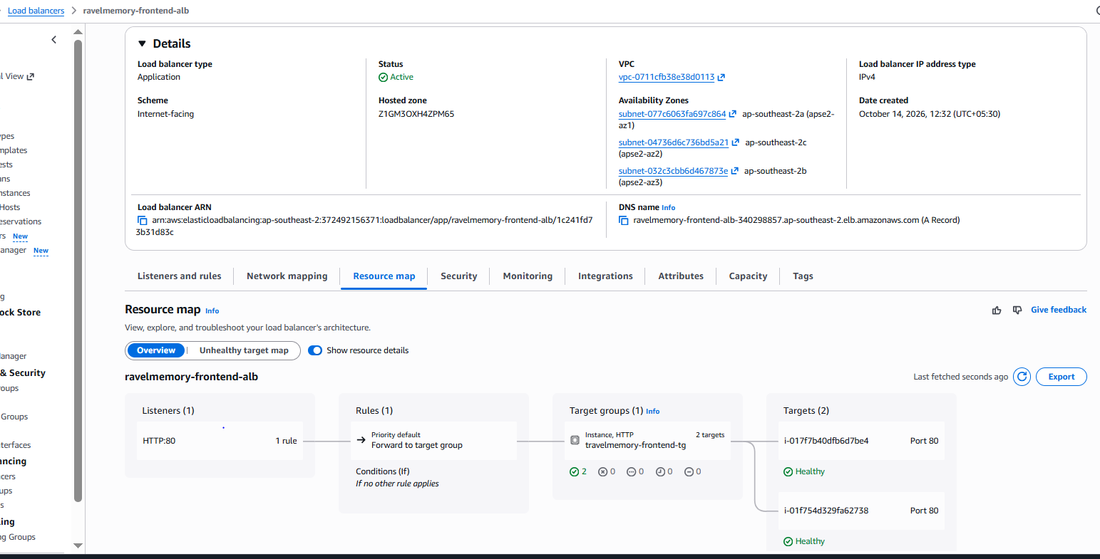
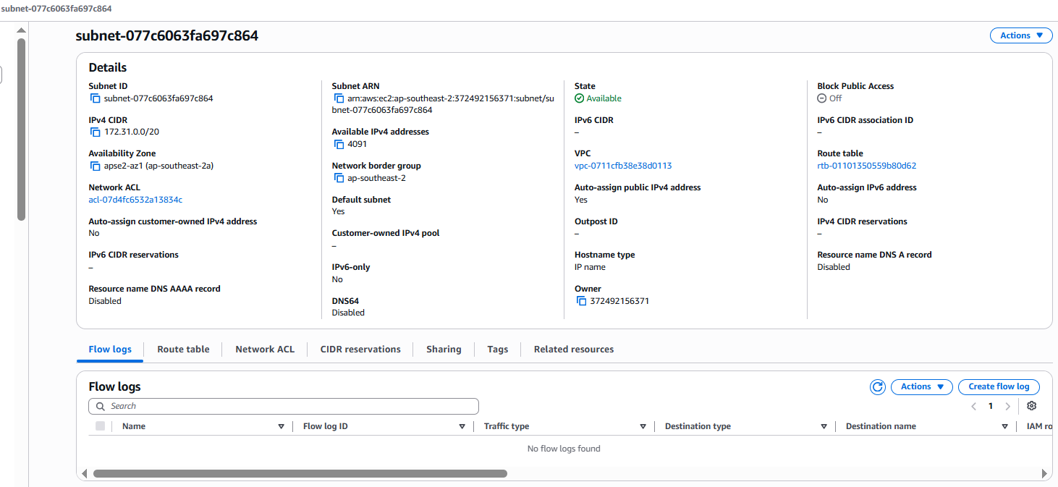
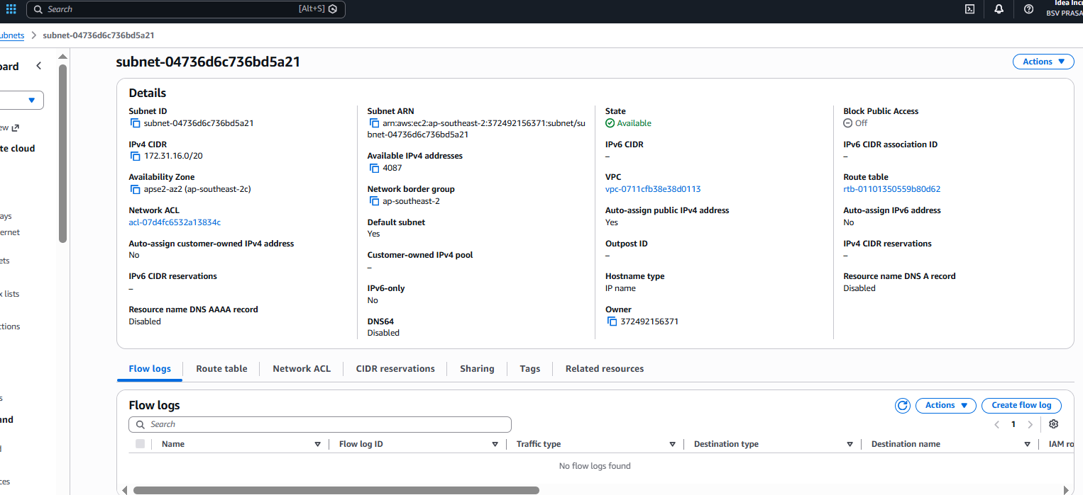
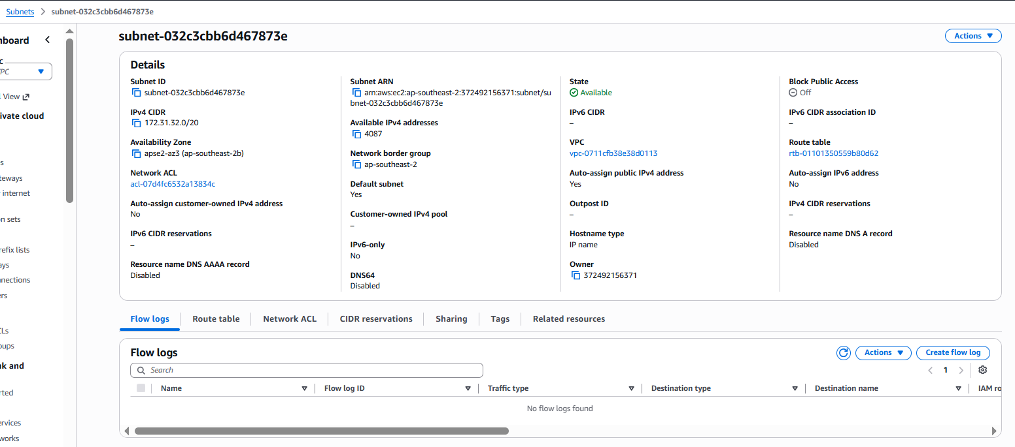

Update the frontend to use the backend ALB
Purpose: Make frontend API requests use the backend load balancer rather than the original backend master's IP.
This step is especially important because the backend ALB is created after the AMIs.
On both frontend instances, update src/url.js in the source repository to use the backend ALB's DNS name. For example:
travelmemory-backend-alb-939012856.ap-southeast-2.elb.amazonaws.com
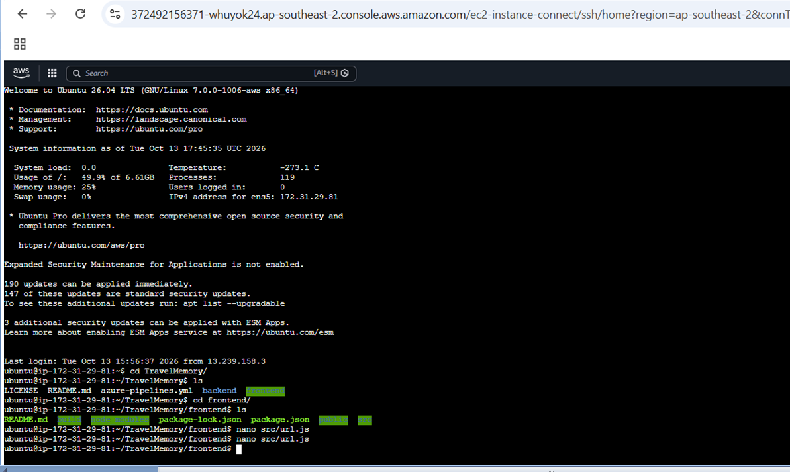

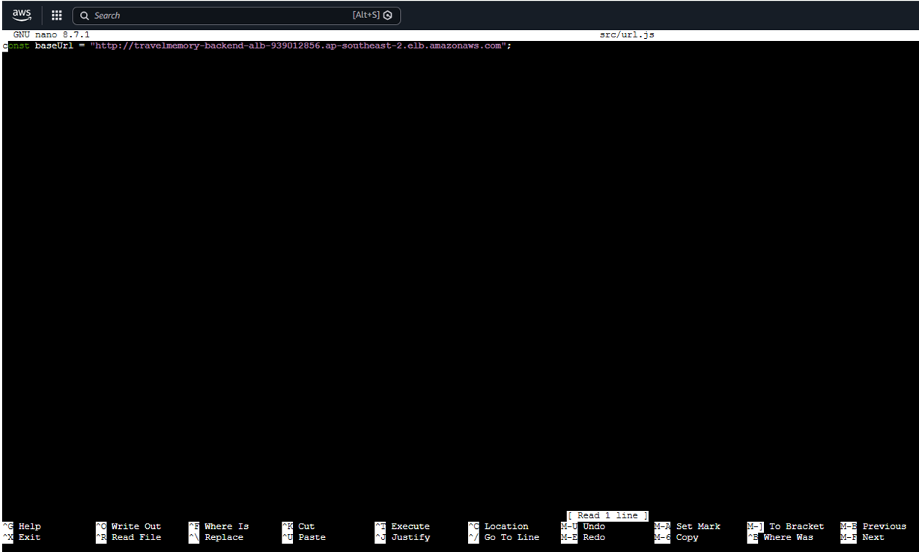 Myec2-Frontend
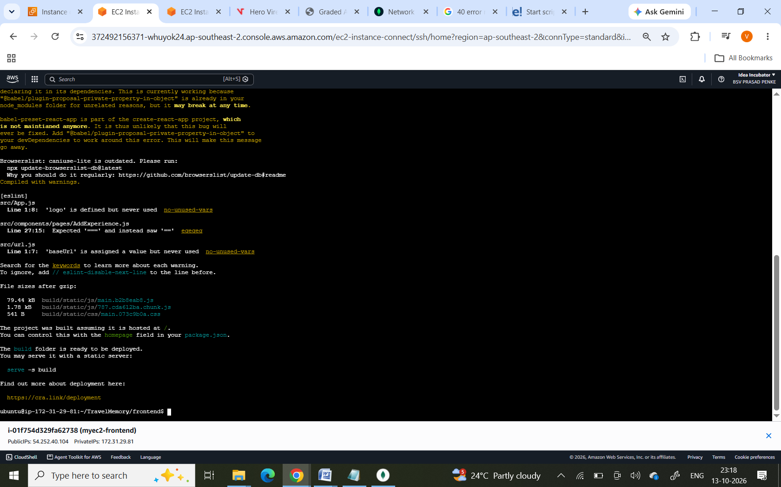
Frontend2
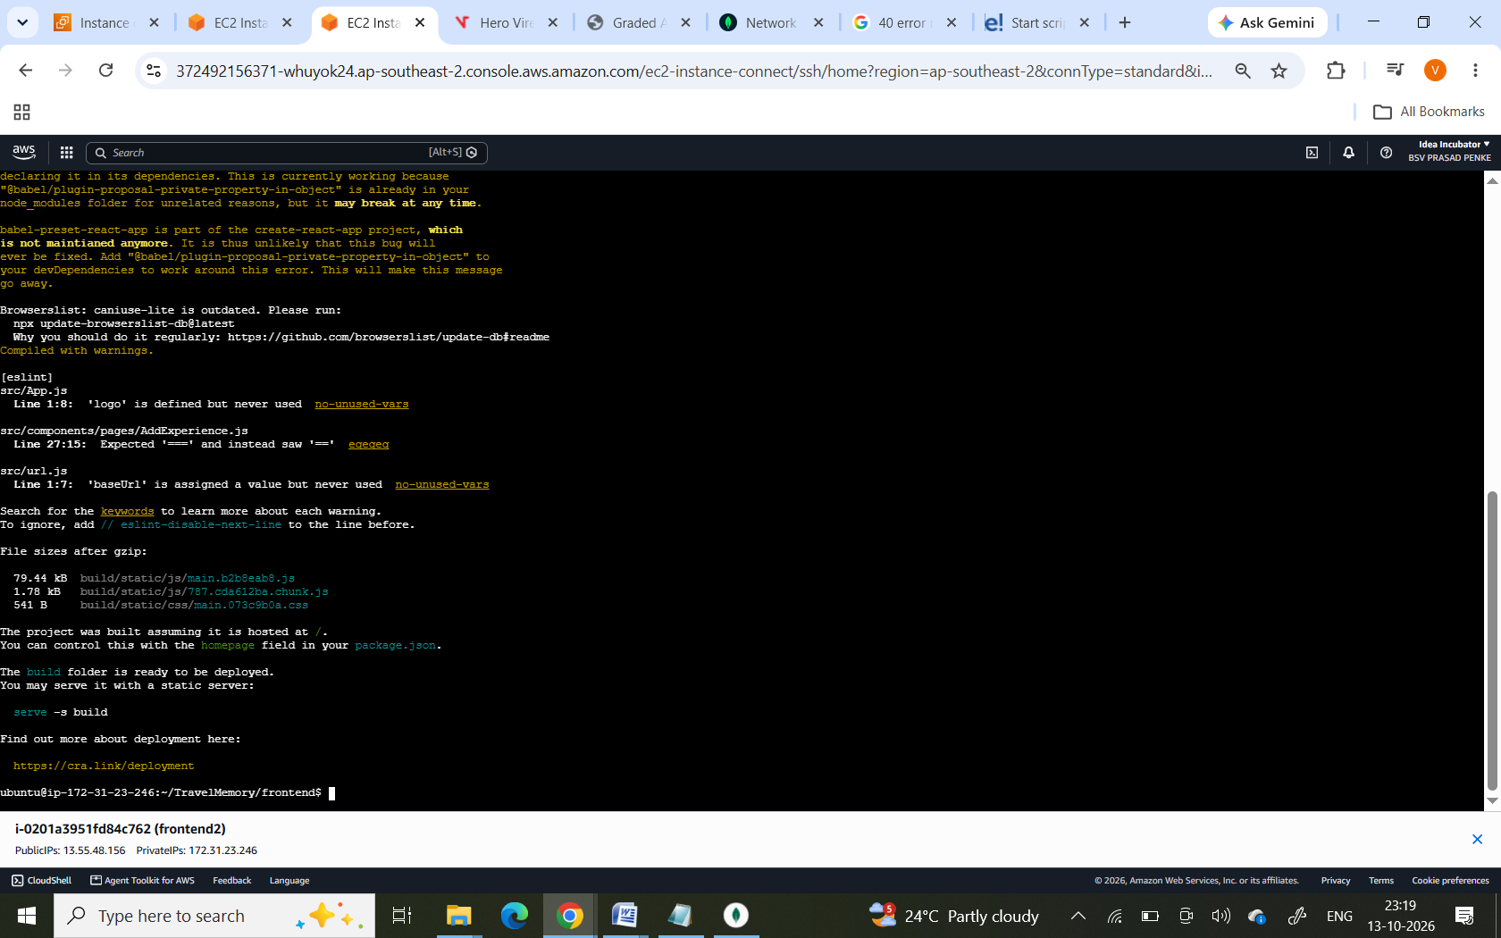
Load the frontend loadbalence url
Add experience and update details.
That will be updated in backend database and shown in browser.
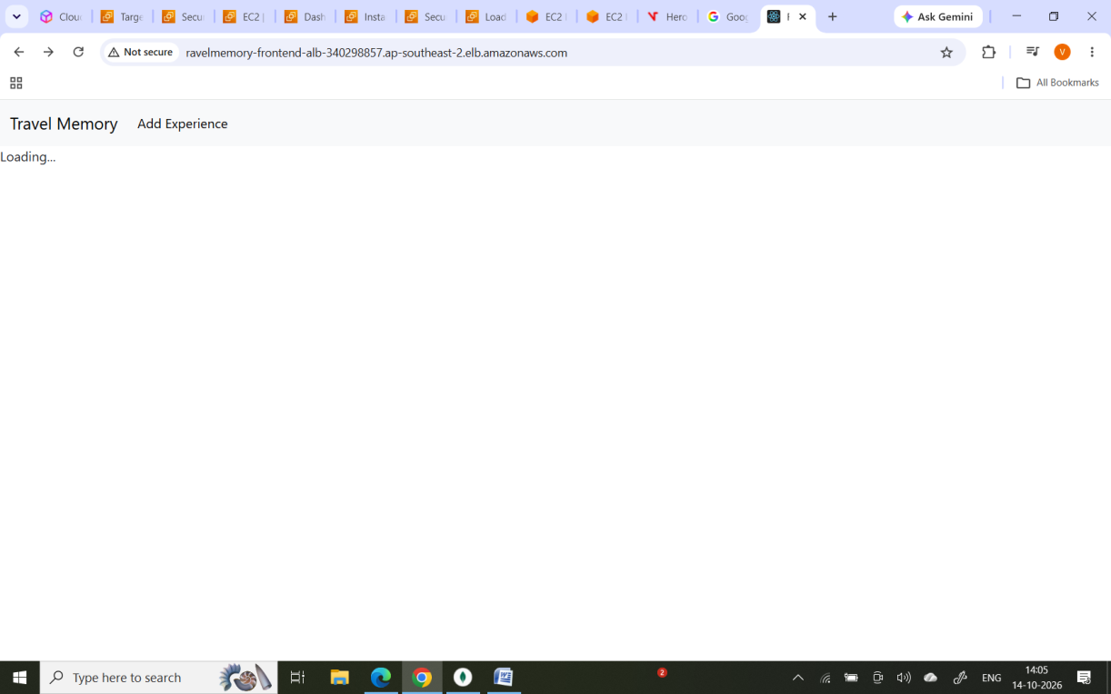
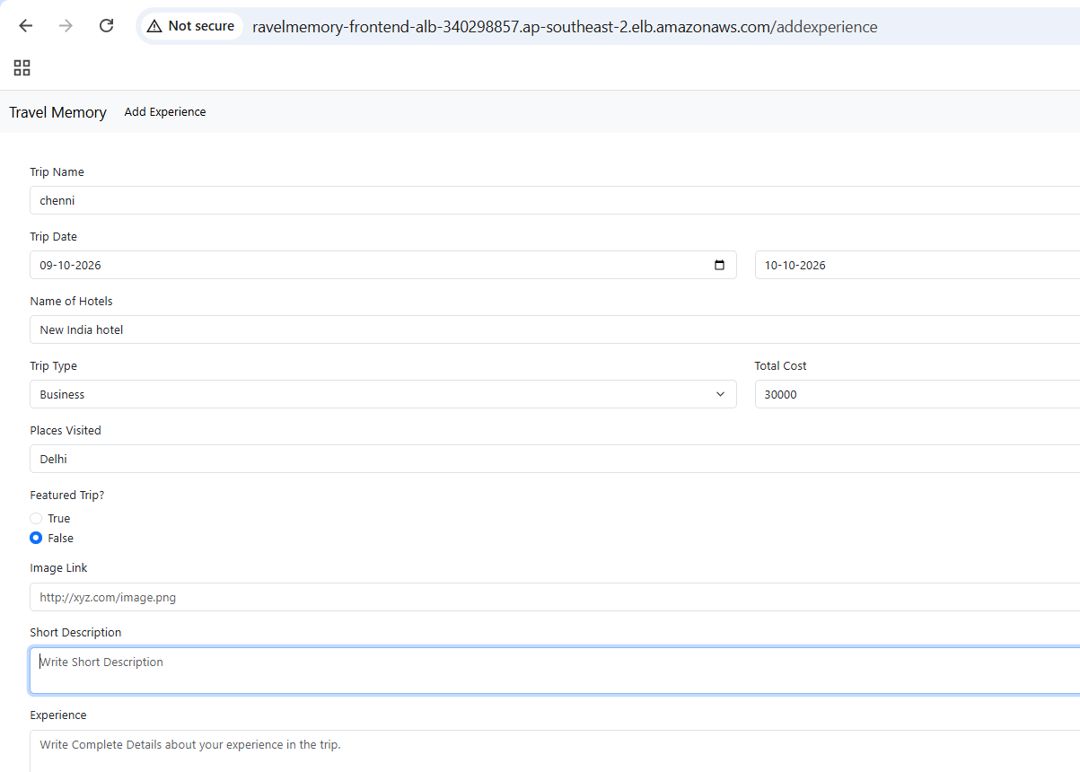
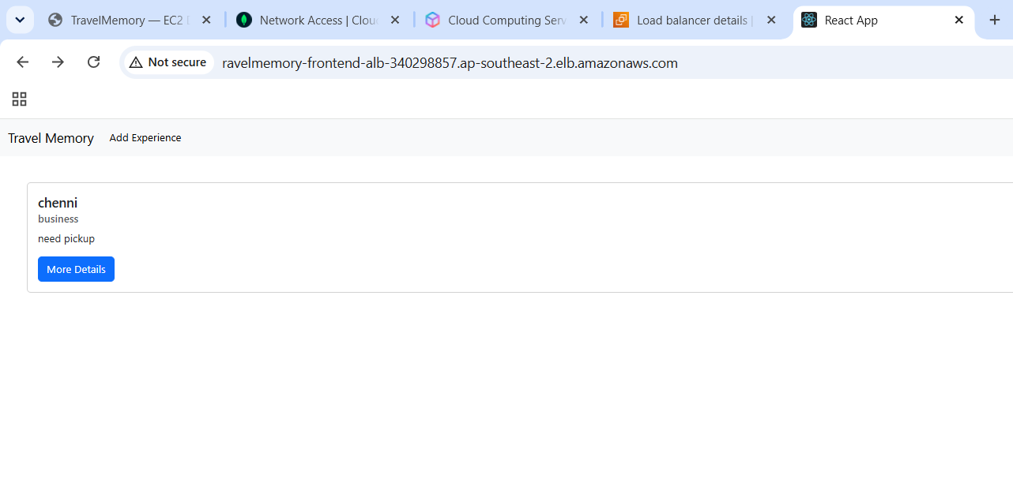

Backend data updated in the Database.
